OFFICIAL INTERNATIONAL PUBLICATION OF THE ASSOC,ATFn , nr

~ ^°^(:ksmithsofamerica. INC

lovember 1

|  |  |  |  |  |
| --- | --- | --- | --- | --- |
| PICKING THROUG | iH | mi | E | VAST ARRAY 1 |
|  |  |  |  |  |

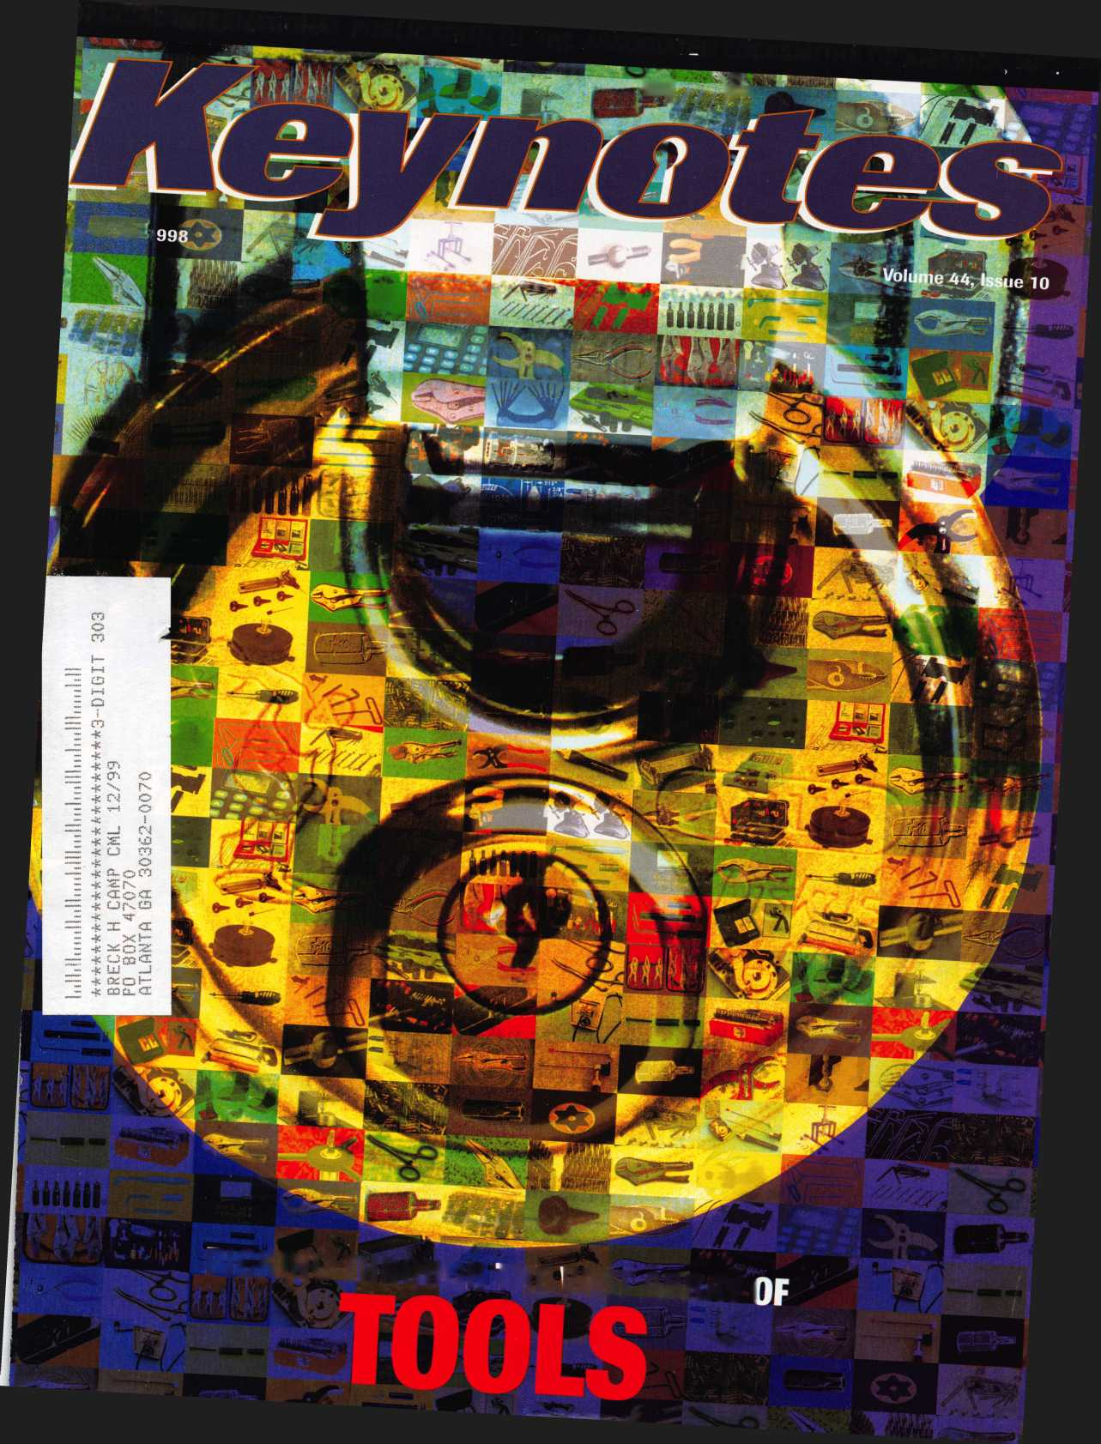

«

You wouldn’t dream of leaving your success  
to chance. You know that making it in the safe  
and vault industry requires hard work, continual  
improvement of techniques, and constant research  
of the latest products and tools.

Your best bet to excel in all these areas is  
SAFETECH ’99 where you can save your luck for  
the casinos, and get down to business viewing  
the latest products, talking with the manufacturers,  
and training in the latest methods of  
safe and vault technology.

t

Make your plans now to attend  
SAFETECH ’99 May 3-8, 1999  
in Las Vegas, NV.



Contact:

Safe and Vault Technicians Association

3003 Live Oak Street Dallas, TX 75204 214.827.7233 214.827.1810 fax email: [convtion@anet-dfw.com](mailto:convtion@anet-dfw.com)

***Reader Service*** #35

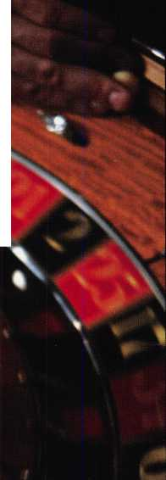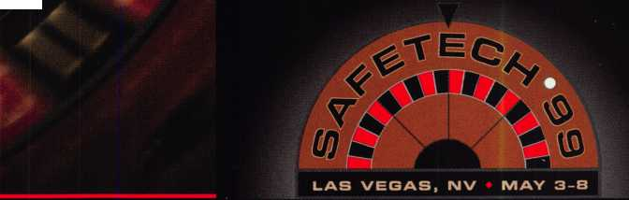

**You could win this UL 950- woith $2,250!**

The early bird gets the ITL950

Wise ALOA members who pay their dues before January 1,1999  
will receive even more than another year’s valuable membership  
in their professional association. They’ll be included in a drawing  
to win this revolutionary code machine donated by Intralock Tools Ltd.  
the ITL950-a $2,250 value!

For more information about the ITL950 contact Intralock Tools Ltd. by phone at 888.264.6627, or write to 2639 Progressive Way,

Unit B, Abbotsford, BC, Canada, V2T 6H8.

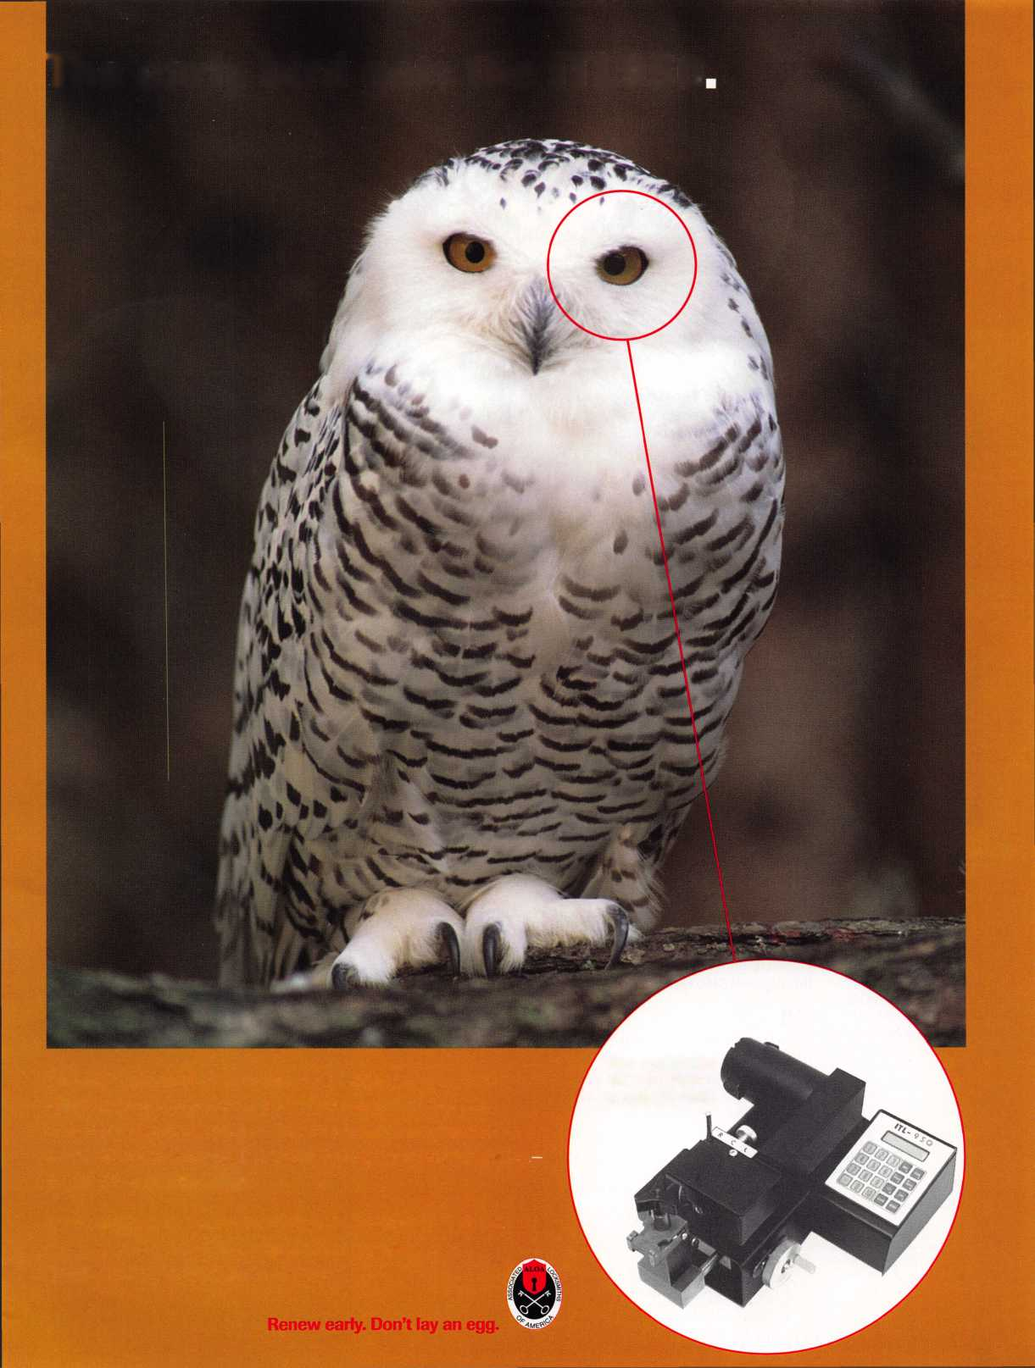

November

Features

4

President s Journey

By Dallas Brooks

16

Is There a Drill Doctor in the House?

Feeling a little dull lately?

Darex Professional Tool Corp. to the rescue.

By Sal Dulcamara, CML

19

A Simple, but Effective Tool  
(to Solve a Major Problem)  
KeyCheck from PRO-LOK will keep you

drawing a blank.

By Steven Spiwak, CRL

Screwdrivers from Keedex

is known for its weldable gate boxes, cylinder guards

other hardware products, but it also produces a variety

interesting locksmith tools.

Sal Dulcamara, CML

Gal! Him Mr. Tibbits

Meet the pioneer of ACE instructor training and  
this year’s recipient of the ALOA Lifetime of  
Outstanding Achievement Award.

Mike Emery

Singertech Lever Neutralizer Tool

interesting new product provides a bypass option

for lever handle locksets.

By Sal Dulcamara, CML

The Cover:

A picture’s worth  
a thousand tools. Not.  
In real life, the right tool  
can make a locksmith’s  
life much easier...and  
a lot more profitable.

The primary image on  
the cover of this issue  
was provided by Abus.  
Look for an Abus  
product review in the  
January 1999 issue.

27

New Life for an Old Install

As a hardware supplier, this author used to see installation jobs with the eye of an artist—make it look good first and worry about function second. As an installer and locksmith, he’s learned that maintenance should come first.

By Greg Perry, CML, CPS

28

Reading the Fine Print of Responsibility in Limited Warranties

It is up to us to educate our customers about

the products we sell and to build a market for quality.

By Paul F. Chandler, CRL

Art direction/design Valerie Rowe

31

Customer Feedback

When and how should you gather customer feedback? Here are some possibilities.

By Claire Cohen, CML



Keynotes

November 1998

Mail Box

Differing opinions on the licensing article in September’

, .

s issue.

Upcoming Events

Next ALOA board meeting, Dec. 10

Applicants for Membership

Scheduled for clearance Dec. 1

Security Marketpla

Tools, catalogs, CCTV

12

Core

Tribute to locksmith veteran Bill Reed

42

Authors in This Issue

32

Associate Members

40

Ad Index

**Departments**

■

36

Classifieds

40

Buyers’ Guide

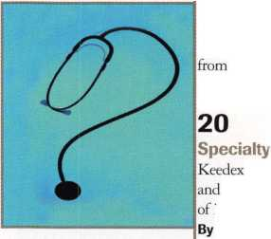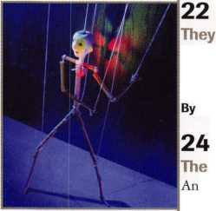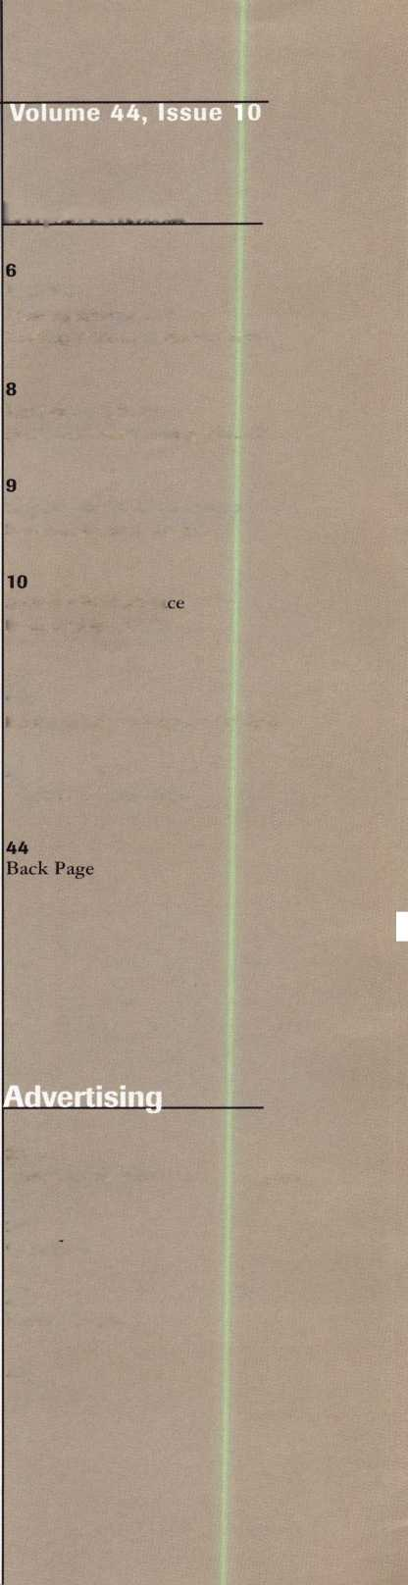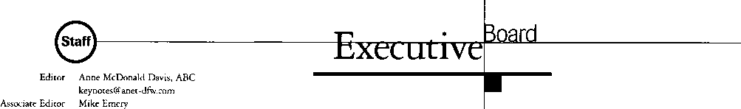

Technical Editor

Editorial Advisor

Advertising Sales Manager

Sales Assistant Contributing Authors

ALOA Professional Staff Executive Director

Operations Manager

Receptionist Comptroller Meetings Manager

Meetings Assistant Government Affairs Manager

PRP/Education Manager

Education Assistant Membership Coordinator

Membership Assistant Chapters & Regional Associations Liaison

[keynotes@anet-dfw.com](mailto:keynotes@anet-dfw.com) David Lowell, CML, CMS [david@aloa.ioffice.com](mailto:david@aloa.ioffice.com) John D. Cannon, CML [jdcannon@worldnet.att.net](mailto:jdcannon@worldnet.att.net) Anelia M. Banda anelia@aloa. ioffice.com Sally Guereca Jerome V. Andrews, CML Paul Chandler, CRL Claire Cohen, CML Brian Costley, CML, CMS Bob De Weese, CPL Ray D’Adamo, CML Sal Dulcamaro, CML James Glazier, CML Daniel Graffeo, CRL, CMS Wayne Gurnee, CRL A.J. Hoffman, CML Ken Holmlund, CRL Ray Lusk, CML Mark Ohno Randy Simpson, CML Steven Spiwak, CRL Robert Stafford, CPL Dave Thielen

Charles W. Gibson, Jr., CAE [charlie@aloa.ioffice.com](mailto:charlie@aloa.ioffice.com) Mary May

[mary@aloa.ioffice.com](mailto:mary@aloa.ioffice.com) Margo E. Vela Kathy J. Romo Jessica Vasquez [jessica@aloa.ioffice.com](mailto:jessica@aloa.ioffice.com) Janelle Vergara Tim McMullen [tim@aloa.ioffice.com](mailto:tim@aloa.ioffice.com) David Lowell, CML, CMS [david@aloa.ioffice.com](mailto:david@aloa.ioffice.com) Ashley Spencer Brandon Durrett [brandon@aloa.ioffice.com](mailto:brandon@aloa.ioffice.com) Jackie Arnett

Tim McMullen [tim@aloa.ioffice.com](mailto:tim@aloa.ioffice.com)

Additional contact information for the ALOA Board and most Keynotes authors are available through “Locksmith Search” on the ALOA website- [www.aloa.org](http://www.aloa.org) or by contacting the ALOA office at 3003 Live Oak Street; Dallas, TX 75204; (214)827-1701; FAX (214) 827-1810; e-mail [aloa@aloa.org](mailto:aloa@aloa.org).



Mission Statement: The Associated Locksmiths of America, Inc. is dedicated to enhancing the professionalism, education and ethics among locksmiths and those in related sectors of the physical security industry. With approximately 10,000 members in the United States, Canada and the freeworld, ALOA is poised to help members obtain the knowledge, the strength, and the confidence to perform their role in the physical security field with pride and dignity. But it is only through active involvement and participation that ALOA can fully achieve its potential-and can help members to achieve theirs.

Policies: Keynoted is the official publication of the Associated Locksmiths of America, Inc. [ALOA], Keynoted acts as a moderator without approving, disapproving, or guaranteeing the validity or accuracy of any data, claim, or opinion appearing under a byline or obtained or quoted from an acknowledged source. The opinions expressed by the authors do not necessarily reflect the official views of ALOA. Also, appearance of advertisements and new products or service information does not constitute an endorsement of products or services featured by the Association. The Association does not accept responsibility for the inaccuracy of any data, claim, or opinion appearing in this publication, due to typographical errors on the part of the authors, Association staff or its agents. Editor’s Note: This publication is designed to provide accurate and authoritative information in regard to the subject matter covered. It is provided and disseminated with the understanding that the publisher is not engaged in rendering legal or other professional services. If legal advice and other expert assistance is required, the services of a competent professional should be sought.

Authors’ Payment: Payment for eligible submissions to Keynotes will be based on the following criteria: topic, time spent and past contributions. Authors who regularly submit to Keynotes are generally paid a higher rate. The latter is especially true of authors who write to fit specific editorial needs and submit said copy by Keynotes deadlines. As a general guideline: Average payment for a 750 word, business or light’ technical article would be $200. Payment for a 1500 word article involving significantly higher time and research efforts would be $400.

Payment will not be offered for articles submitted by ALOA employees or members of the ALOA Board of Directors (unless material is of a technical nature), nor for articles submitted by a company that promote that company’s products or services. ALOA reserves the right not to pay for articles submitted by an individuals) that promote a particular company’s products or services.

Disclaimer: The Associated Locksmiths of America, Inc., (ALOA), reserves the right to refuse any article for any reason. Additionally, ALOA reserves the right to edit, amend or modify any article submitted for publication in order to preserve technical accuracy, clarity, fairness or grammatical correctness. ALOA will make the best efforts to notify the author of any changes. The extent of ALOA’s liability for any article or information contained therein will be a notice of correction or retraction in the next possible issue.

Keynotes® (ISSN 0277 0792) is published monthly except for the combined June/July issue by The Associated Locksmiths of America, Inc., 3003 Live Oak St., Dallas, TX 75204-6186. Telephone: (214) 827-1701; FAX (214) 827-1810: e-mail [aloa@aloa.org](mailto:aloa@aloa.org). Subscription rates for members-$ 15.00 per year. Second class postage paid at Dallas, Texas. POSTMASTER: Send address changes to: Keynotes, 3003 Live Oak St., Dallas, TX 75204-6186. © Copyright 1998, All rights reserved. No part of the contents may be reproduced or reprinted in any form without prior written permission of the publisher.

President

Dallas C. Brooks (334) 826-8990

Regional Vice Presidents Southeast

♦Jeffrey S. Nunberg, CML, CMS

(305) 324-8800

North Central

♦John J. Greenan

(773) 486-2030

South Central

■Randy L. Simpson, CML

1. 780-7026 Southwest

John I. Shandy, CML

(303) 776-7898

Northeast

James H. Glazier, CML

(301) 831-5454

Northwest

Raymond C. Lusk, CML

(509) 624-3152

Secretary

John D. Cannon, CML

(703) 960-6413

Trustees:

David M. Lowell, CML, CMS (214) 827-1701 Breck H. Camp, CML (770) 455-6244 Henry H. Printz, CML (201) 538-2737 Leonard J. Passarello, CPL (416) 752-7210 Edwin Toepfer, RL (416) 225-5589 Directors

*These officers also serve as directors.

Dana L. Barnum, CML

(610) 565-9900

MarkE. Blum, CML, CPS

(517) 482-5809

AJ. Hoffman, CML

1. 572-6008 Barry K. Leas, CRL (610) 650-9292

Clyde Roberson, CML, CPS (540) 380-5000 Donald E. Rul6. CML (601) 324-2658

Anthony J. Ramunno, CML, CPS

(330) 782-6204

Robert H. Stafford, CPL

(860) 768-7917

Bruce J. Tarbet, CML

(601) 924-4184

Chairmen of International Affairs

Laurence P. Mills/Australia (129) 958-0445 Hans Mejlshede, CML/Europe FAX (453) 139-1004 Members-at-Large Jerome V. Andrews, CML (860) 621-3601 Steven G. Engel, CML, CPP (414) 731-5400

Past Presidents

1995-1997 David Lowell, CML, CMS 1993-1995 Breck Camp, CML 1991-1993 Henry Printz, CML 1989-1991 Evelyn Wersonick, CML, CPS 1987-1989 Leonard Passarello, CPL 1985-1987 Joe Jackman, CML 1983-1985 Stanley Haney, CPL 1981-1983 Louis LaGreco, CPL 1979-1981 John Kerr, RL 1977-1979 Clifford Cox, CML 1974-1977 Charles Hetherington 1972-1974 Gene Laughridge 1970-1972 William Dutcher, RL 1968-1970 Constant Maffrey, RL 1966-1968 Harold Edelstein, RL 1964-1966 William Meacham 1962-1964 Robert Rackliffe, CPL 1960-1962 Edwin Toepfer, RL 1956-1960 Ernest Johannesen

November 1998

***Keynotes*** U

with Dallas Brooks



■

Last month I predicted a 20% ballot return in our new vote-by-mail process.

I am very happy to report that as of today’s date we are already close to that number and we still have two weeks to go. I want to thank all of you who took the few moments needed to mark your ballot and drop it in the mail. Thank you for doing YOUR part! Thank you for not letting me down, I knew you would come through when given the opportunity!

By the time this issue of KEYNOTES is in your hands, the votes will have been tabulated and the election results posted on ALOA’s web site,

HYPERLINK <http://www.aloa.org>. The results will also be published in the December issue of KEYNOTES. Thanks again for the support you have shown forALOA.

While my enthusiasm for our new voting process is very high, I am deeply saddened by the loss last month of one our industry leaders, Bill Reed. Everyone who knew Bill, is aware of his love and devotion to this Industry. He felt the locksmith industry had been good to him and he had been working hard to give something back to it. I have heard him make that comment many times over the last few years. He was a great supporter of all locksmiths associations, especially ALOA. Our condolences go out to Bills wife, Caroline, his family, and to his dear friend and partner, Steve Young. Bill was an industry giant in every sense of the word. We will all miss him.

Your newly elected Board of Directors will be having it’s first meeting the second week of December. A large portion of our first meeting will be spent learning such things as; what is expected from a board member; what is the proper role in the association governance process of the board of directors, the president, the executive director, the staff. The next item on our agenda will be reviewing the role of the association as a whole to its members. We have to answer some tough questions, such as; What should the association be providing to it’s members? Are we providing these things, and if not, why not? We may not walk away from this first meeting with all the answers, but I do expect the entire board to leave this meeting with the desire to find the answers. And I truly believe the way to find the answers will be through communications between you and your regional board member. You can assist greatly in this process by attending your local association meetings, inviting your board member to attend, and discussing the issues with him or her.

Working together is the answer to improving our association.

(MLc&JL

Dallas C. Brooks President

November 1998

J Keynotes

Kwok-kei Leung

MembersHenry Raymond

Toshihiro Asano

Stewart Levine, CML

Mary Ohmit, CPL

Charles Robertson, CML.

Yuriko Yanai

Jack Hobin, CPL

Allen Konrath

Salvatore Dulcamaro, CML

Myeong-Rae Cho

William Neff, CML

Thomas Freehling, CML

David Lowell, CML

Jeanne Lodge, CML _ John Heckman, CML _

J Thomas Hood, CML_

Roy Renderer, CML

John Elliott, CML

|  |  |
| --- | --- |
| L/dlliiy r\uuu, V.I L.  Larry Warnick, CML | 24 |
| Robert Carroll, CPL | 23 |
| James Watt, CML | 23 |
| Diana Barnum, CRL | 22 |
| Robert DeWeese, CPL | 22 |
| David M A Federico | 22 |
| Barbara Watt | 22 |
| Jim Williams | 22 |
| Eugene Altobella | 21 |
| Jerome Cohen, CML | 21 |
| Charles Cole, CML | 19 |
| James Fowler, CML | 18 |
| Elvis Hammerschmidt, CPL | 18 |
| David Harris, CML | 18 |
| D Michael Lee, CPL | 18 |
| John Dorsey, CPL | 17 |
| Ronald Heidzig | 17 |
| lnhn kprrr RL | 17 |
| Marian Swann, CRL | 17 |
| James Cawby, CML | 16 |
| Joseph Ferrero, CML | 16 |
| William Grant, CRL | 16 |
| Scott Henke, CRL | 16 |
| Rrian Rppt7 | 16 |
| Michael Robinson, CRL | 16 |
| Philip Rovenolt, CPL | 16 |
| Walter Lascar, RL | 15 |
| William McElheney, CML | 15 |
| Gary Teams, CPL | 15 |
| Thomas Vandersteen, CML | 15 |
| James Gruber, CRL | 14 |
| Rex Parmelee, RL | 14 |
| Russell Fuller, CRL | 13 |
| Peter Gauthier, CPL | 13 |
| Frank Hartung, CML | 13 |
| Edwin W Scott | 13 |
| Paul ^nnhpr | 13 |
| Keizo Takahashi | 13 |
| Rolando Bouza | 12 |

Best.

|  |  |
| --- | --- |
| James Brickler, CRL | 12 |
| Robert Duman, CML | 12 |
| Jon Griswold, CML | 12 |
| Joe Lee, CRL | 12 |
| Daniel Landry | 12 |
| Lonnie McKinney, CML | 12 |
| Robert Rodocker, CRL | 12 |
| Richard Sievers | 12 |
| Steven Spiwak, CRL | 12 |
| Frir Vpal | 12 |
| Herbert Dusenberry, CML | 11 |
| John Engel, CRL | 11 |
| Robin Horsley | 11 |
| nnnald Shilps | 11 |
| Lester Brodsky | 10 |
| Thomas Demont, CML | 10 |
| Dale Knowles, CPL | 10 |
| Lawrence F. Smith, Jr. | 10 |
| Frnp<;t Wright | 10 |
| William Wickward, CML | 10 |
| Joseph Whitaker, CPL | 10 |

What do I get?

When you recruit 10 members, you receive a handsome blue blazer with a President's Club crest. For each additional five members you recruit, you receive a lapel pin with gold-filled numbers, indicating your recruiting successes.

You also get the satisfaction of knowing that you are helping your association, helping your industry grow, and you are helping fellow locksmiths achieve success,

How do I get started?

Contact the ALOA office for a supply of applications (214) 827-1701 or FAX (214) 827-1810. One President's Club credit is awarded for each new applicant. Credit is awarded only after the membership application is approved. However, the credit will apply for the period in which the application is received. Failure to identify yourself as the sponsor on the application form at the time it is submitted to ALOA for processing will forfeit any credit.

*•ALOA* Board of Directors not eligible for membership in the President's Club.

club by

prestigious

ecruiting just 10 new members for ALOA.  
"Anv ALOA member may participate.



Keynotes

Mail Box



Dept

**If you have an opinion to offer on the letter(s) printed in** Keynotes **each month, let us know! Submissions to the** “Keynotes **Mail Box” department are printed on a space-available basis. Write to:** Keynotes **Mail Box; Associated Locksmiths of America, Inc.; 3003 Live Oak Street; Dallas, TX 75204; or FAX (214) 827-1810.**

Point-Counterpoint One Member's Opinion

Why does anti-licensing propaganda deserve editorial space? Page 7, Keynotes Sept. ’98 lists one of the eight ALOA tenets as lobbying the decision of spending our dollars to watch and guide licensing was made by ALOA several years ago. To now question the viability of licensing gives a mixed signal to members. Either this article was base sensationalism or our association is adrift without compass or rudder.

Gale Johnson #10460

Point-Counterpoint Editor's Reply

Gale, I hope you don’t mind that I sent a copy of your fax to Dallas Brooks since he was the final word in the difficult decision on whether to run the licensing debate article. None of us enjoyed being in that position, but I will tell you that it was my recommendation that we run the article, and I will tell you why.

Yes, ALOA leadership has made a collective decision regarding licensing, and I believe it is a sound decision that can stand up to scrutiny and debate. It is my understanding that Keynotes belongs to the members of ALOA, and that this publication exists to provide an open and honest forum for a variety of opinions. I believe that it is not only wrong, but that it is a mistake to perpetuate a reputation for censorship-for only covering the points of view that please those in authority at ALOA.

Also, I do not think it fair to label Mr. Dulcamaro’s opinion, as expressed, as propaganda. I found his questions understandable and thoughtfully expressed.

I also thought Ms. Zaniolo nailed hers down admirably. Neither do I think that ALOA was sending a “mixed message” to members. The stand that ALOA leadership has taken on licensing is clear. It is also common knowledge that not all members agree with that direction. The fact that ALOA has the confidence to acknowledge

those differences bespeaks the kind of strength and credibility that a democratic association should be known for.

Without this type of editorial integrity,

I don’t think ALOA can claim Keynotes as a true member benefit. I’m proud that I work for people who apparently agree with that. Anne Davis, Editor Keynotes

Point-Counterpoint More From Gale

Kathy Zaniolo and I have served on the board of the Greater Chicago Locksmith Association for several years. I know that her sole occupation is the operation of a locksmith store in suburban Chicago. Kathy has volunteered her time to make the field of locksmithing better for everyone in Illinois by spearheading legislation. I have been present when she has been pounded with questions about licensing. Nobody asks questions any more because Illinois licensing is working.

According to the people I have talked with in Michigan, Sal Dulcamaro teaches a locksmithing course to apprentices, writes articles for at least two publications, publishes the newsletter for his association and operates a locksmith business in his home. I do not question the knowledge of Mr. Dulcamaro, but in my opinion, his views fit his situation as a part-time locksmith. He is appealing to the very people in our business who want to have their locksmith business and charge unrealistic prices while not having the training to do much more than open cars. The people give reputable locksmith businesspeople a bad image.

ALOA should be at the forefront of raising the image, reputation and earning power of locksmiths. By appealing to the lowest common denominator, you effectively drive away the movers and shakers and end up with people who cannot afford classes or the expense of travel to conventions. Does that sound familiar?

Articles such as those by Mr. Dulcamaro only make the job of trying to raise the stature of locksmithing that much harder.

Gale Johnson #10460

Point-Counterpoint Author's Reply

To license or not to license, that is the question. When I first wrote the article about licensing, it was a free standing piece. It wasn’t the first part of a point/ counterpoint. Anne Davis, the professional that she is, realized that it might be controversial and requested an opposing view to mine. My article standing alone might have been misinterpreted as ALOA’s viewpoint. I can assure everyone that my opinion pieces are strictly my own, and don’t represent the views or interests of any others or other organizations.

I take exception to the term “propaganda” used in reference to my commentary. Some may suggest that my impressions are mistaken or misguided, if they disagree as they are free to do. I know the meaning of the word propaganda, and those who know me, know that I don’t engage in it. I take the pursuit of truth seriously, and though I don’t always find it, I don’t play games with the tmth. A minor complication could have been the slightly rearranged text in my article, that differed from what I sent to the magazine. Some misplaced words, here and there, changed the meaning of a few statements that I made. Still, with misprints included, the article stated my case.

I discussed general principles and mentioned nobody by name. More importantly, I wasn’t even thinking of any specific people when I repeated general statements for and against licensing that I had heard over the years. The coincidence of Ms. Zaniolo being the author of the counterpoint piece, may have given the appearance of my remarks about California and Illinois being pointed in her direction or others behind the Illinois licensing coalition. I only chose those two states because they

Keynotes

November 1998

were examples of a few large states where licensing had been enacted. Before writing the article, I wasn’t aware of who had been behind the effort in Illinois or what their motives were.

I will say what motives I had. My motives are consistent with my philosophical princi­ples and were intended to find the wisest course. I am 40, and my philosophy has been gradually leaning in the libertarian direction over the last 15 years or so. I don’t belong to the libertarian or any other politi­cal party, so what I describe as libertarian philosophy may bear absolutely no resem­blance to the stands taken by that organiza­tion. I believe that rights belong to individ­uals rather than groups. I think it is inappro­priate for the government to needlessly interfere with the actions of a citizen who causes no harm to others.

In a free market, honest competition should decide who gets the customer dollars. If you don’t think your competitor does as good a job as you, you can advertise to point out the differences. It is not the business of the government to decide that Kroger food stores don’t make enough profit, so A & P food stores should have to close their doors earlier in the evening to force customers to buy from Kroger. My opinion has nothing to do with my being a full, or part time, locksmith (or dentist). It is a principled stand. If I concede that the government can interfere for my financial gain at someone else’s expense, I have no right to complain when someone with a bigger political gift manages to make the law take from me and give to someone else. We have complained when the alarm industry bought politicians to squeeze us out of legitimate areas of our profession. We are no better than they, if we imitate their actions.

It is ironic that I had not taken an absolute stand against licensing in my arti­cle, but was looking for persuasive argu­ments to help me overcome my doubts. When I read Kathy’s piece, I thought she had made some interesting comments. I didn’t know what circumstances she and

others (in Illinois) faced regarding licensing, and had come to the conclusion (whether or not she was right or wrong) that she had a lot of guts to do what she did. She, after all, would become a lightning rod for every problem caused by licensing, justified or not.

At this point, I take Gale Johnson at his word (knowing him to be an honorable man and locksmith) that the law is working out for the best. I know I’m currently taking on more tasks than a rational human being should, but I’d like to hear from locksmiths living with licensing laws (not necessarily Illinois, but anywhere). It doesn’t have to be bad experiences. I’d like to know how things changed for better or worse following the enactment of locksmith licensing. I would prefer letters to phone calls, since my time is already over committed. Keep them as short as possible, and I’ll try to do a follow up arti­cle on the subject in the near future, based on the information I gather from respon­dents. I may not be able to personally respond to every letter, but I’ll try to use them all to give me a clearer and more full picture of locksmith licensing in the U.S. Send them to:

Sal Dulcamaro 19559 14 Mile Road Clinton Twp., Ml48935

Any Opinion, Readers?

How do you like to see industry issues covered? Do you...(a) like to see different opinions expressed or do you (b) find that confusing and prefer for your national association to take a stand and concentrate on communicating that point of view?

The fact is, there’s no one correct way to cover an issue as complex as licensing, and there’s cer­tainly no easy way. In the end, it’s really up to you, the members of ALOA, to decide how you want your association run. Let us know.

More on PADO

You ran an article in the September 1998 editions called “Unusual Locks/Unusual Methods,” where one of our PADO

Keynotes

Mail Box

Cylinders was shown and a method for rekeying. We were pleasantly surprised to have our cylinder presented in your maga­zine, however, the author was missing a few issues that I thought might be of interest to your readers.

First, the author was correct in his assumption that these cylinders are Brazilian made. The company that makes them is PADO S.A. and is located in Sao Paulo, Brazil. We ar PADO Security, Inc. and we are located in New Orleans, La. We use the name only [to identify the lock} and are a separate company, privately owned. WE are the only source in the USA for the PADO line of locks, cylinders and trim hardware. We have many other items in specialty door lock hardware from narrow stile locks to German Multipoint Locks and Trim.

FYI: The cylinder the author was using is an older model and no longer made. The new cylinder (several years old actually) does not have the long pin shown in the pho­tographs. Instead, we now use pin chamber caps as mentioned in the last paragraph of the first column. This makes the job of rekeying a bit more complicated. But, this should not be considered a problem for the locksmith because we have several new solu­tions for your readership. We will be happy to send a catalog of our products to anyone interested. Your readers may call us at (800) 5233-9877. We can be emailed at: [pado007@aol.com](mailto:pado007@aol.com).

Jay George

Operations Manager, PADO Security, Inc.

November 1998

***Keynotes*** H

Upcoming

Events

Indicates ALOA ACE Class Indicates PRP Sitting

NOVEMBER

8

ALOA PRP SITTING Sponsor: Ohio Valley Chapter Dayton, Ohio Contact: Bob Sutton, CPL (937) 836-6127

13-14

Door and Hardware Institute Creation of Education Foundation Dallas, TX

Contact: Donna Munari (703) 222-2010 (703) 222-2410 fax

16-20

Mark Bates Associates DoD/DoE Combination Locks class Nicholasville, KY 40356-1830 Contact: Paula Bates (606) 887-0496 (606) 887-9491 fax

21-22

Mark Bates Associates Professional Safe Drilling class Nicholasville, KY 40356-1850 Contact: Paula Bates (606) 887-0496 (606) 887-9491 fax

DECEMBER

5

Grand Canyon Chapter Annual Meeting and Banquet Wyndham Garden Hotel Tempe, AZ 85281 Contact: John Ilk, CRL (602) 921-0123 (602) 425-9566 (after 5 pm)

10

ALOA Fall Board Meeting Dallas, Texas (214) 827-1701

12

# ALOA PRP SITTING Georgia Chapter Atlanta, GA

Contact: Steve Gebbia, CML (770) 455-6242



***Keynotes***

1999

JANUARY

9

ALOA PRP SITTING Locksmith Security Association Detroit, MI

Contact: Sal Dulcamara, CML (810) 791-5416 (810) 792-4021 fax

FEBRUARY

9-14

Texas Locksmiths Association Annual Convention and Trade Show Contact: Jim Hetchler (registration) (830) 606-1727 or Pat Titus (booth space) (210) 649-2166

14

**f/** ALOA PRP SITTING Texas Locksmiths Association San Antonio, Texas Contact: Wanda Robbins (210) 923-4381 (210) 977-8398 fax

20-21

C^ACE Class

Fundamentals of Masterkeying Grand Canyon Chapter of ALOA Phoenix, Ariz.

Contact: John Ilk, CRL (602) 921-0123 (602) 921-0524

28

**f/** ALOA PRP SITTING Western Michigan Locksmiths Association, Kalamazoo, Mich. Contact: Terry L. Bussema, CRL (616) 381-5634 (616) 381-5654 fax

28

Local Organizations for Continuing Education—South Florida Locksmiths Association/

Florida Latin Locksmiths Contact: Jerri (days) (305) 944- 0469; or Wayne (evenings)

(305) 252-8355

MARCH

12-14

IDN Hardware Sales, Inc. Security Conference Cleveland, Ohio 44122 Contact: Fred Strasberger, John Kress or Bonnie Weston (800) 521-0955

20

r ALOA PRP SITTING Sponsor: MLANJ Somerset, NJ

Contact: Bill Timann, CML (732) 424-7827

17-21

V **'.-** ACE Classes

Sponsor: MLANJ Annual Convention Somerset, NJ Contact: (732) 424-7827 [www.mlanj.org](http://www.mlanj.org)

APRIL

ii

**^** ALOA PRP SITTING Montana Chapter of ALOA Butte, Mont.

Cooneys Locksmith Contact: Walter P Cooney, CML (406) 782-0125 (406) 782-0125 fax

MAY

4-9

SAFETECH ‘99 Las Vegas, Nev.

Contact: (214) 827-7233

JULY

25-31

ALOA ’99 Security Expo Cincinnati, Ohio Contact: (214) 827-1701

AUGUST

27-30

MLA’s London Convention Contact: Dave Stokes 139 Wood Street Walthamstow, London, E17 3LX 01144 181 520 7450

2000

APRIL

5-9

MLANJ 2000 Annual Convention Somerset, NJ Contact: (732) 424-7827 [www.mlanj](http://www.mlanj) .org

MAY

5-10

SAFETECH 2000 Birmingham, Ala. Contact: (214) 827-7233

JULY

17-22

ALOA 2000 Las Vegas, Nev.

Contact: (214)827-1701

2001

MARCH

28 - April 9

MLANJ 2001 Annual Convention Somerset, NJ Contact: (732) 424-7827 [www.mlanj.org](http://www.mlanj.org)

JULY

15-21

ALOA 2001 Security Expo Baltimore, Md.

Contact: (214) 827-1701

2002

JULY

21 -27

ALOA 2002 Security Expo Rosemont, 111.

Contact: (214) 827-1701

November 1998

Applicants

For Membership

Dept

*The following applicants are scheduled for clearance as members of  
ALOA. The names are published for member review and comment prior to  
December 1, 1998, to ensure applicants meet standards of ALOA’s Code of  
Ethics. Protests, if any, should be addressed to the Membership Department  
and must be signed. Active Membership applicants (A) have worked in the  
industry two or more years. Allied Membership (AL) applicants are not  
locksmiths, but work in a security-related field. Apprentice Membership (AP)  
applicants have worked in the industry less than two years.*

USA

ARKANSAS

Fayetteville

028503, Terry W Sharp, A SPONSOR: Billy Reves

CALIFORNIA

Concord

028531, Tom E Appel, A SPONSOR: James Parrie

Culver City

028536, CliffS Bara, A SPONSOR: Daniel Enriquez 028535, Ralph A Gomez, A SPONSOR: Daniel Enriquez

Fremont

028533, Steven M Goldstein, A SPONSOR: George Miley

Garden Grove

028519, Alma Engelsman, A SPONSOR: Julie McCluney

CONNECTICUT

Westport

028507, Ward L Kaye, A SPONSOR: William Dinter

DISTRICT OF COLUMBIA Washington

028534, Dainer Robinson, A SPONSOR: Philip Rovenolt

GEORGIA

Tlfton

028505, Howard M Allen, A SPONSOR: James Eaton

IOWA

Bettendorf

028539, Daniel L Schafer, A SPONSOR: Timothy Meegan

INDIANA New Castle

028511, Rodney Anderson, A

LOUISIANA

Metairie

028541, Frederick J Parker, A

MICHIGAN

Detroit

028512, Thomas A Brown, A 028515, John H Henry, A 028517, Rickey D Reynolds, A 028514, Cleadis N Smith, A 028513, Randolph Stevens, A 028516, William D Young, A Durand

028532, Karen M Thomas, AP SPONSOR: Salvatore Dulcamaro

Flint

028528, Jeffreys Gale, A SPONSOR: Daniel Hackney

MINNESOTA

Edina

028527, KyleJMadara, A

NEW HAMPSHIRE Exeter

028502, Marshal J Miller, A SPONSOR: Peter Roche

NEW JERSEY Newark

028506, Charles P Phillips, A

W Trenton

028529, Thomas M Negron, A SPONSOR: John Greenan

OHIO

Cincinnati

028521, Jeffrey L Boyd, A

OREGON

Portland

028520, Keith O Elliott, A SPONSOR: David Drog

PENNSYLVANIA

Downingtown

028500, William C Saar, A SPONSOR: D Franklin

Harrisburg

028501, Kenneth F Bowen, A SPONSOR: Rod Snell

TENNESSEE

Nashville

028530, Nathan E Hansen, AP SPONSOR: C Halverson

TEXAS

Dallas

028518, Rogelio Gomez, AP SPONSOR: Randy Hutchison

El Paso

028508, William L Blea, A SPONSOR: William Fury

UTAH

Bluffdale

028509, Dennis B Thompson, A

Midvale

028510, Troy D Mehr, A

VIRGINIA

Roanoke

028522, David M Frydrych, A

VERMONT

Burlington

028540, Robert W Gorton, A SPONSOR: Milagros Dion

WASHINGTON

Wenatchee

028543, Ryan J Crockett, AP SPONSOR: Jeanne Lodge 028542, John MGrupp, AP SPONSOR: Jeanne Lodge 028544, Paul F Horner, AP SPONSOR: Jeanne Lodge

CANADA

ONTARIO

Toronto

028504, Andrew M D’Cruz, A

JAPAN

Anjo-City Aichi

028524, Hiroshi Nishio, A SPONSOR: Toshihiro Asano

Itabashi-Ku Tokyo

028526, Yoshihiro Tobo, A SPONSOR: Toshihiro Asano

Shinjuku-ku Tokyo

028525, Yukiko Wakabayashi, A SPONSOR: Toshihiro Asano

Tokyo

028523, Taichi Matsui, A SPONSOR: Toshihiro Asano

KOREA

KOREA

Seoul

028537, Chung-Ki Min, A SPONSOR: Myeong-Rae Cho 028538, Cheoul-Ho Shin, A SPONSOR: Myeong-Rae Cho

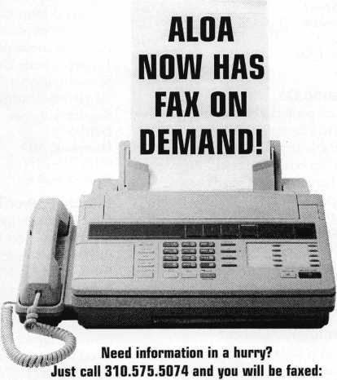

#1 A list of all documents available through this service #2 Becoming A Locksmith #3 Locksmith Career Summary #4 Locksmith School List #5 ACE Class Schedule #6 Certification Information #7 PRP Category List #8 ALOA Membership Application #9 ALOA List of Benefits

#10 Scholarship Application Form #11 ALOA Video Library Order Form #12 ALOA Membership Items Order Form #13 Safe & Vault Technicians Association Member Application/Subscription Form #14 ALOA Chapter Roster #15 Legislative Action Network #16 Legislative Action Network Newsletters #17 Various State Laws #18 Industry Position Paper

Your association continues to explore ways to prouide you,  
our members, with new benefits and services.

9

November 1998

Keynotes



Security

Marketplace

Securitron

Securitron offers two different Touch Sense Devices. The push bar version is called the TSB-3 and the pull handle version is called the TSH series. The Model TSB-3 comes attractively designed in clear and black finishes in three different door opening lengths that may be modified in the field to accommodate non-standard door openings. It is complete with 16 feet of cable and door cord along with mounting fasteners to fit metal or wood doors. The Model TSH comes complete with reversible handle, offset spacer, electronics, 16 feet of cable and door cord, and engraved plated designating Pull/Push and blank plates in gray and black.

Securitron (702) 355-5625 (702) 355-5636fax ***Reader Service #2***

GBC/CCTV Corp.

The GBC Mini-Max 700 Series are ultra­miniature black and white cameras. The CCD-700 with 4mm lens (optional 2.3 mm, 6 mm, 8 mm and 12 mm), the CCD- 700PH with 3.6 mm pinhole lends (optional 3.5 mm pinhole lens) or the CCD 700CS that accommodates a “C”/“CS” lens. CCTV Corp.

280 Huyler Street South Hackensack, NJ 07606 (800) 221-2240 (201) 489-0111 fax ***Reader Service #3***

Trans-Atlantic Co.

Trans-Atlantic padlocks are designed, so that the cylinder can be changed and rekeyed. They’re available keyed “differently” and keyed “alike” in boxes and cards. They’re available in hardened steel satin chrome plated shackle.

Trans-Atlantic Co.

440 Fairmount Ave.

PO Box 37006 Philadelphia, PA 19123 (800) 531-0844 (215) 629-1282fax

Reader Service #4

Control Concepts/Liebert

Control Concepts/Liebert recently announced a new interconnect assembly-for systems with parallel surge protection devices (SPD) that minimize voltage drops. The AccuGuide High Performance SPD Interconnect Assembly offers interconnect coaxial cables that transmit transients generated by lightning and switching with minimal voltage drops. AccuGuide cable is required for each protected mode, and each cable minimizes inductance through a reduced coaxial aspect ratio and features a low impedance. Also from Control Concepts is a new add-on device for integration with electronic panelboards at the



job site for surge suppression. The PanelGuard Extension provides integrated surge suppression. It has flexible mounting and a universal panelboard application.

Control ConceptsILiebert Corporation 328 Water St.

PO Box 1389

Binghamton, NY 13902-1380 (607) 724-2484

Reader Service **#5**

Security Lock Distributors

Security Lock Distributors now carries the complete line of National Guard saddles and door opening accessories. Included are saddle and half saddle threshold styles, panic and ADA varieties, brass/bronze types as well as door bottoms, seals, gasketing, and other accessories and components.

Security Lock Distributors 40 A Street

Needham Heights, MA 02194 (800) 847-5625

(800) 878-6400fax seclock@ix. netcom.cwn ***Reader Service* *#6***

DeWalt

DeWalt’s Professional Set Case is constructed of industrial grade ABS material for maximum durability. It features a sliding rubber lock to help keep the case closed and an interlocking hinge. The bit holder system keeps bits in place and identifies each size. Available in the professional set case are a 17-piece Oxide Drill Bit Set, 13 piece Screwdriving Set, 21 piece Screwdriving Set, 29-piece Screwdriving Set and a 37-piece Screwdriving Set.

DeWalt

Hamstead, MD (410) 716-7271 ***Reader Service* #7**

Hitachi Power Tools

Hitachi Power Tools announced it will introduce an 188 Volt Cordless Driver Drill in 1999- It will feature a 2.0 amp-hour battery and has 1/2-inch chuck capacity. It will weigh 5.3 pounds and provide 278 inch pounds of torque. Drilling capacity is 1/2" in diameter for mild steel and 1 13/32" in diameter for soft wood. It can accommodate wood screws up to 20 x 3" and machine screws up to 1/4" in diameter.

Hitachi Power Tools 3950 Steve Reynolds Blvd.

Norcross, GA 30093 (770)925-1774 (770) 923-2117 fax ***Reader Service* *#8***

Streamlight, Inc.

Streamlight, Inc. Has introduced Stinger XT, an enhanced tactical version of the Stinger flashlight that features a rubber button tailcap switch that is easy to find in any orientation and conveniently combines

both monetary and constant “on” operation. The Stinger XT’s high intensity xenon gas- filled bulb produces a variable spot-to-flood beam of up to 15,000 candlepower for up to one hour of continuous use.

Streamlight, Inc.

1030 West Germantown Pike Norristown, PA 19403 ***Reader Service #9***

Marks USA

Marks USA has altered its “Survivor” cylindrical locksets, so that they may operate in different door conditions. The lockset is self-adjusting within 1 5/8" to 1-1-7/8" door thickness, installs with just two #10 through bolts. It is available in both the standard American style lever and the more rounded Crescent Style. Both feature “Clutch” mechanisms and are made in both ANSI grades (one and two).

Marks USA

5300 New Horizons Blvd.

Amityville, NY 11701 (516) 225-5400 (516) 225-6136fax ***Reader Service #10***

Panasonic Video Imaging Systems Company

Panasonic Video Imaging Systems Company (PVISC) recently introduced a collection of new products that include cameras, 1 /3-inch lenses, integrated camera devices, time lapse recorders, DVD-RAM and CODEC units. Among Panasonic new products are the WV-CP230 Series Color DSP Cameras, WV-CF202 Color, WV-BF102 Black and White mini-dome Cameras, WV-CS654 Super Dynamic Unitized Camera, AG-6540 High Density Time Lapse VCR and AG-RT600A Real Motion VCR.

Panasonic Video Imaging Systems Company One Panasonic Way Secaucus, NJ 07094 ***Reader Service #11***

Magnet-Schultz of America, Inc.

Magnet-Schultz of America introduced the addition of Model HI 6x12 to its line of solenoids. Also called a spool lock solenoid because it was designed to act as a safety interlock for a spool in a hydraulic valve, preventing actuation during unsafe or improper conditions. Designs are available with the ability to “energize to lock” or “energize to unlock,” so that it unlocks the spool in place, which prevents unwanted movements. It has a threaded front end that allows direct mounting to the valve and access to the spool.

Magnet Schultz of America, Inc.

401 Plaza Drive Westmont, IL. 60559 (800) 635-3778 (630) 789-0614 fax ***Reader Service #12***

***Keynotes***

November 1998

ALOA SCHOLARSHIP FOUNDATION, INC.

ALOA/SAVTA SCHOLARSHIP APPLICATION  
3003 Live Oak Street; Dallas TX 75204; (214) 827-1701

Please print or type

NAMEPRP LEVELALOA/SAVTA#

HOME ADDRESSCITYSTATE ZIP

HOME PHONE -DOBEDUCATIONAL LEVEL **(YEARS)** DEGREE, IF ANY

PRESENT EMPLOYERWORK PHONEFAX

WORK ADDRESSCITYSTATE ZIP

POSITIONFULL TIME PART TIME TAKE HOME PAY

LENGTH OF TIME IN LOCKSMITHINGOWNER/SUPERVISOR’S FULL NAME MEMBERSHIP IN TRADE ASSOCIATIONS (LIST BY NAME)

MARITAL STATUSSPOUSE’S OCCUPATIONSPOUSE’S TAKE HOME PAY

COMBINED HOUSEHOLD ADJUSTED GROSS INCOMENUMBER OF DEPENDENTS

CLASSES DESIREDDATE OF CLASSES

ORGANIZATION SPONSORING CLASSES: ALOA SAVTA OTHERLOCATION

ALOA Scholarships are granted to selected individuals desirous of entering the locksmithing field or to selected individuals already in the locksmithing field who wish to improve their professional skills through education.

Applications for classes being taken locally must be received a minimum of 60 days prior to the date of the class, and will be reviewed as they are submitted. Scholarships for classes at the ALOA or SAVTA convention will be awarded each year at the ALOA Scholarship Foundation meeting preceding the convention and must be received by March 1 each year.

Please attach to this form a letter stating your reason for applying for a scholarship, what you plan to do with the knowledge you obtain and any other information you feel may be helpful to the scholarship board in making its decision. In addition, attach three letters of reference from individuals who have personal knowledge of your background and character. The letters should contain their names, addresses and phone numbers. It would be helpful if at least one of these references is an ALOA or SAVTA member. Also, please provide a copy of your most recent tax return.

All scholarship recipients will be required to provide a 3 X 5 inch photograph of themselves.

APPLICATION CHECK LIST

Only complete applications will be considered for scholarships. An application is considered incomplete unless ALL of the above requested information is received before the deadline: 60 days prior to the date of a class or March 1 for ALOA/SAVTA convention classes. Please send this application after checking off each of the below.

* I have filled in each blank on this form.
* I have written and enclosed a letter explaining my reason for applying.
* I have enclosed three letters of reference.
* I have enclosed a copy of my most recent tax return.
* I am submitting this in time to be received 60 days prior to the date of a class or by March 1 for ALOA/SAVTA convention classes.

CERTIFICATION OF APPLICANT:

I certify that the information contained herein, and all supplemental forms are complete and correct to the best of my knowledge. I further certify that if i am selected as a scholarship recipient i will use the knowledge gained for the improvement, development and advancement of the locksmithing profession.

SignatureDate 4/98

ID Systems

ID Systems is introducing its Digital Radio Frequency (RF) system. The RF DSP 9000 combines RF microelectronics and DSP (Digital Signal Processing). The specifi­cations per antenna are as follows: height-60.63", width-12.6", depth—3.9", weight—17.64 lbs., material—brushed steel and plexiglass, power—110 or 220 Volt.

ID Systems

37 Voyager Court North Toronto, Ontario M9W 4Y2 (416) 674-4788; (416) 674-3073 fax [idsales@idsystems-dialoc.com](mailto:idsales@idsystems-dialoc.com) http:llunvw. idsystems-dialoc.com ***Reader Service* #13**

Cold Steel

Cold Steel’s Para Edge line of knives can be used as utility or rescue tools. Neck knives are designed to be suspended from the neck by a lightweight paracord lanyard in sheaths. All Para Edge knives feature a three inch fixed blade made from 1.8 inch thick AUS 6A stainless steel, high carbon and low chromium steel. Blades are available in Spear Point, Double Edge Point, Clip Point and Tanto Point. Non-slip Kraton handles are incorporated as well.

Cold Steel

2128-D Knoll Drive Ventura, CA 93003 (800) 233-4716 ***Reader Service #14***

Intromark, Inc.

Intromark Incorporated introduced Security Latch Opener, a tool that enables proper authorities to disengage door security latches from the outside during emergencies. If someone cannot make it to the door or releases the security hatch because of personal injury, unconsciousness, fire or other emergency situation, rescuers could access entry with the Opener. Suggested price is $20.

Intromark, Inc.

217 Ninth St.

Pittsburgh, PA 13222-3306 ***(800)831-6030 Reader Service* #15**

Jensen Tools, Inc.

Jensen Tools has released a 308-page color catalog. This comprehensive reference guide features Jensen-brand products including 50 pages of original JTK tool kits, a handheld JTM multimeter and hand tools. Other items include test equipment, computer and LAN, wire and cable, telecom, power tools, soldering, storage and handling, work stations, lighting and optical, shop supplies and communications products.

Jensen Tools, Inc.

7813 S. 46Th St.

Phoenix, AZ 83044-3399

(602) 968-6241; (602) 438-1690fax

Reader Service #16

CCS International, Ltd.

Spy Cam-11 is a camera with a built-in modem that allows the user to view the action from across the city or across an ocean. The system handles from one to 26 cameras, so you can see simultaneously what’s happening. It transmits via telephone line or cell phone to any PC or laptop computer equipped with standard modem and Spy Cam-11 receiving software. It can be programmed to alert the user when preset conditions have been breached and will record the event that triggered them.

CCS International, Ltd.

360 Madison Are.

New York, NY 10017 ***Reader Service* #17**

United States

Consumer Information Center

Out now is the Fall 1998 Consumer Information Catalog. Available from the U.S. Consumer Information Center, it contains more than 200 free and federal informational booklets. Among the topics in these booklets are “assistance with consumer problems,” “how to stay healthy,” “save money,” “educate children,” “buy a car or home,” “food safety” and “getting federal benefits.”

United States Consumer Information Center

Pueblo, CO 81009

(888) 8 PUEBLO

[www.pueblo.gsa.gov](http://www.pueblo.gsa.gov)

Reader Service #18

KroyLLC

Kroy, Inc., a manufacturer of bar-code and label printers recently introduced the K2000-PC label and bar code printer.

It connects to a personal computer and prints graphics, logos, bar codes and data records onto a wide range of label supply. The user can select from economical direct-thermal labels, industrial labels that are heat and chemical resistant, a tamper evident supply, shrink tubing to mark wires or cables and general-purpose or die-cut labels. Suggested retail price of the K2000-PC label printer is $199. KroyLLC

14333 N. Hayden Rd.

Scottsdale, AZ 83260-3443 (602) 948-2222 ***Reader Service #19***

TRA-SEC

TRA-SEC’s DoorBlocker is constructed from 11 gauge stainless steel and has an industrial straight line action clamp. It is built and computer tested to withstand over 800 lbs. of pressure and can be carried in luggage. DoorBlocker is available in two models- #1000, which is portable for travel and apartments, and #2000, which is a permanent mount for doors with thresholds-homes and apartments.

Security

Marketplace

TRA-SEC 10906 202nd Ave.

NW Elk River, MN 33330 (612) 441-3838 wtvw.doorblocker.com ***Reader Service #20***

Intellimar/Skyline Mills

Skyline Mills’ Safetydrape was developed for use on governmental, commercial and international facilities subject to bombing threats associated with domestic and international terrorism. Created in response to the bombing of the Alfred Murrah Federal Building in Oklahoma City, Safetydrape is designed to protect federal facilities against similar threats. The product is lightweight and transparent, making its aesthetic appearance similar to that of a window sheer.

Intellimar PO Box 1074 Columbia, MD 21044 (301) 396-8300 (301) 396-8833 fax [INTELLIMAR@aol.com](mailto:INTELLIMAR@aol.com) ***Reader Service #21***

American Lock Company

American Lock Company introduces a 2 3/4" solid brass rectangle lock with a protected, locking bolt shackle. The lock, also known as a “warehouse lock,” is used to secure self-storage facilities, garages, storefront roll-up doors and coin operated devices, such as newspaper vending machines. It is designed to endure harsh weather conditions and temperature extremes.

American Lock 3400 W. Exchange Crete, 1160417-2099 (708) 334-2000 (708)334-0331 fax ***Reader Service #22***

Chicago Lock Company

Chicago Lock Company recently introduced BarLOC, which features a rotary disk tumbler mechanism with a front anti-drill plate and a hardened steel body and shackle. It’s offered in three body sizes and designed with interchangeable shackles. The shackles, available in three lengths for each body size, are easy to change. A large plastic key handle provides ease of operation. The key may also be inserted in either direction. Chicago Lock Company (800) 443-3204

Reader Service #23

November 1998

***Keynotes***

core

• Good-bye

To an Industry Leader

ALOA mourns the loss of longtime member and industry figurehead, William K. “Bill” Reed. Bill passed away at the age of 58 on Sept. 30, 1998.

A third-generation locksmith, Reed was the director of Tech-Train Productions and co-founder of Security Resources, Inc. He was also an instrumental figure within the publishing aspect of the security industry, serving as editor and publisher of Locksmith Ledger (1974-93) and Reed’s Security Reporter (1993-95).

Among the numerous industry awards that he was honored with were: The Don Davis Memorial Award, the Gold Key Award, The Philadelphia Award, the Ernest Johannesen Award, and the Lee Rognon Award.

He was also a member of Who’s Who in Security and the American Society for Industrial Security.

Among his other contributions to the industry was the LedgerWorld Seminars, which have been instrumental in educating locksmith and security professionals.

Bill is survived by his wife and co-worker at Security Resources, Inc., Caroline.



Keynotes

November 1998

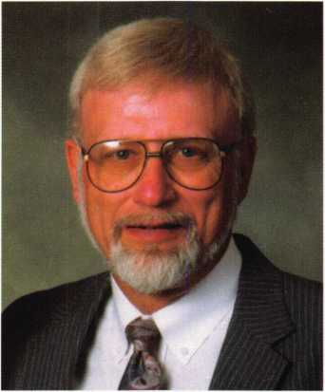

In a posted statement on Clearstar, his close friend and associate, Tech-Train founder, Steve Young said, “He was without a doubt, the most caring man I have ever known. Bill tmly cared for everyone. Not the superficial kind of ‘caring’ that so many of us see in our day-to-day lives, but a real ‘from the heart’ kind of caring that cost Bill a great deal more than most people would believe. He gave of himself, even when it hurt, whenever he thought he could help a locksmith, or advance the industry as a whole.”

* Expanding Dorma

Dorma recently announced the formation of the Dorma Group North America. Described by the company as “a new umbrella marketing visibility,” it will encompass several Dorma operating units. These will include:

* Dorma Door Controls Inc., which will begin marketing as Dorma Architectural Hardware
* Dorma Automatics, which manufactures and markets automatic swinging, sliding, folding and revolving doors.
* Dorma Glas, manufacturing hardware for fully tempered heavy glass entrances and sliding/stacking glass wall systems; and
* Dorma Canada, which will market the products of Dorma Architectural Hardware, Automatics and Glass

in Canada.

Aiphone products are now being stocked at Security Lock Distributors (800.847.5625). Aiphone manufacturers a wide range of intercoms. ...

Curtis Industries, Inc. has announced a new Internet-based sales order delivery tracking system through the company’s website, [www.curtisindustries.com](http://www.curtisindustries.com). ... The Door and Hardware Institute will unveil its latest “New Product Showcase” during their convention and exposition in Orlando (see “Upcoming Events,” p.8).... JLM Wholesale (800.522.2940) is now stocking the new 9100 and CM9100 series electric strikes by Locknetics.

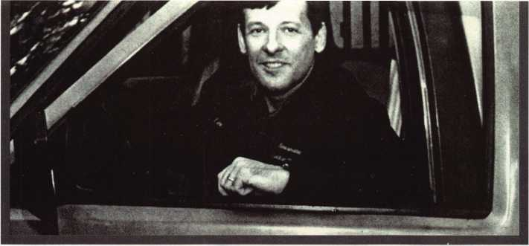

* Locksmith to the Rescue

Who says locksmiths cant be recognized as heroes? Sure, most people seem to think that a locksmith s job consists solely of picking locks or rekeying doors. Sometimes, however, these skills can save the day when something as precious as an infant is left in a locked automobile.

Recently, that was the case in Montrose, NY when a woman accidentally locked herself out of her ’98 Mercedes Benz while her five-month-old daughter was still inside. To make matters even worse, a bee was looming inside the car, making the already worried mother even more frightened.

After using the old “wire hanger trick” and consulting both police and a tow truck driver, she was still unable to open the car.

That’s when Leland Imm (#18989) sprang into the action. Called to the scene by police, Imm (the owner of Montrose’s Reasonable Locksmithing), was able to use his skills and resources to quickly open the car.

“I’ve gotten several calls for situations like this,” he says. “Mentally, what I try to do is get as much information as possible, so I’ll know what tools and procedures are recom­mended for a particular opening.”

After rescuing the baby girl, Imm didn’t even accept payment for his time or services

* Congratulations!

At the Greater Philadelphia Locksmith Association’s 49th Annual Banquet, several individuals were honored with awards and thanks for their contributions to the industry.

James H. “Jim” Glazier, CML

was the proud recipient of the prestigious “Philadelphia Award.”

Also honored was Evelyn Wersonick,

CML, CPS. Evelyn is a past ALOA president and past “Philadelphia Award” winner. The special presentation “A Salute to

which he says is just a way of him repaying his community.

He says that such occurrences are commonplace and remembers the first time he received a call regarding a locked car with baby inside.

“The first time I got a call for something like this, I got really anxious,” he says. “Then I thought to myself that I need to give myself two or three options to open this vehicle. One is handling the lock-out with the recommended method, the other is picking, and the third would be an alterna­tive with another tool.”

The most recent baby-in-the-locked car incident received attention from the local press in the Montrose area, which pleases him. Not that Imm likes the spotlight on himself, but rather he feels that if anything, such press can only help the image of locksmiths as helping hands.

“This is the first time anything I’ve done like this has been written up in the newspaper,” he says. “Sometimes, people hear negative things about locksmiths, so aside from helping a woman get her baby out of her car, I was pleased that residents in my area were able to learn that we can be a positive force in the community as well.”

— Mike Emery

Women in Locksmithing” was dedicated to her for her continued excellence within the field of locksmithing.

MUL-T-LOCK received the Industry Award for its contribution to the growth and stature of the industry.

Mary Ohmit, CPL was also on-hand as she was presented with “Gerald J. Connelly Pioneer Award” for her innovative contributions to locksmithing leadership and education.

...Imm didn’t even accept payment for his time or services, which he says is just a way of repaying his community.

• correction to “GM Progression”

October 1998 Keynotes—

A small correction to “General Motors Progression 101” in the last issue was noted by locksmithing wizard Roger Weitzenkamp, CML. The fourth rule shown as applying to all five-depth General Motors Keys is incorrect.

There are various codes (such as 22M2 and F526) with combination 444244.

Thanks for the catch, Roger.

November 1998

Keynotes **L_**

core

• legislative briefs

Pay Special Attention to Local Elections

On Tuesday, Nov. 7,1998, ALOA members will go to the polls to vote in state and national elections. You probably know who your Congressman and Senators are, but do you know who your state Representative and state Senator are? How do they stand on licensing? Are they the chairperson of a committee that will consider any alarm licensing legislation that is introduced?

The two best resources you have to find the answer to these questions is your local ALOA chapter or regional locksmith association and ALOA’s Government Affairs department. Tim McMullen, Government Affairs Manager is more than happy to help you identify your local representative, and whether they serve on a key committee. And while ALOA would never tell you who to vote for, it's nice to be an informed voter. Your local group will also have insight on politicians who they may have a great working relationship as well.

Fax On Demand Provides Members With Up-To-The- Minute Legislative Information

ALOA’s Government Affairs department is proud to announce our new fax-on-demand service for members. This innovative way of getting the latest legislative information will provide you with current state licensing laws, the latest ALOA Security Industry Position Paper supporters, and the recent Legislative Action Network Newsletter (see ad p.9.) Just phone (310)575-5074.

When The SAINTS Go Marching In

ALOA is leading the way in an effort to help rebuild and secure churches recently destroyed by arson. We are combining our efforts with several security industry associations and the Congress of National Black Churches, Inc. (CNBC), forming the Safety Awareness and Independence Through Security (SAINTS) Program. ALOA’s goal is to have each chapter and regional locksmith association donate time and materials to help maintain the safety of these churches from future attacks. We are concentrating on 26 selected churches throughout Alabama, Arkansas, Florida, Georgia, Tennessee, Missouri, Oklahoma, South Carolina and Texas. Members interested in participating should call Tim McMullen, Chapters and Regional Associations Liaison for more information: (214) 827-1701 Member volunteers will receive a SAINTS-logo hat, not to mention great publicity.

14

November 1998

**spotlight news**

• Keeping an Anonymous Eye on Medical Records

Two security innovators recently joined forces to develop a new system for protecting medical records.

Anonymous Data Corporation and IriScan, Inc. began an joint agreement to create an Iriscode system that will operate on anonymous coding and iris recognition technology. It will secure confidential informa­tion relating to medical records and bodily fluid tests through biometrics.

Thus far, the testing process has consisted of anonymous participants using their individualized Iriscodes as identification, so that only the individual who owns the test results can access them.

Other applications for the device will include securing such personal medical data such as as genetic testing, infectious disease testing, employer/employee drug testing and other areas subject to FDA approval and mutually agreed upon by ADC and IriScan.

• Happy Birthday SHDA!

The Security Hardware Distributors Association recently celebrated its 50th anniversary. The organization (once known as NLSA) began in 1948 when a handful of distributors came together with the goal of sharing information and educating its members.

During its earliest days as an organized entity, SHDA worked closely with and assisted ALOA in becoming locksmi thing’s premiere national association.

In 1969, SHDA began to allow manufacturers into its fold. Shortly thereafter, it held the first ever conference for both distributors and manufacturers to gather and discuss industry issues. It was also around this time that the Ben Silver seminar (named for a chief founder of the association) became a staple event for all members.

Now, 50 years after its conception, SHDA has more than 150 distributor and manufacturer members. Happy Birthday!

• He Got the Shirt

The lucky winner of the “Give Me the Shirt” drawing was Leo Volkmann, #23109, who guessed the correct answer to the “Back Page” quiz in the September issue. Leo says that he plans to wear the black ALOA golf shirt to his Minnesota chapter meetings to encourage interest in attending the ALOA convention next year. We were impressed that many of the entrants were already enthused about ALOA ’99 Convention and Security Expo to be held July 25-31, 1999, in Cincinnati, Ohio. Maybe, just maybe, we’ll be sending a little something convention related to those folks ... In any event, thanks to all of you for entering! Watch “Back Page” this issue and every issue through next July’s. There will be more drawings, more prizes, more fun stuff about the city of water.

Keynotes

* prp

CRLs

Bruce L. Akers, El Cajon, Calif.

Rodney P. Blanchard, New Orleans, La. Scott E. Hansen, Yankton, South Dakota Theodore W. Havens, Sulphur, La.

Joey Lafleur, Lake Charles, La.

Stephen Miller, Media, Pa.

Peter Nelson, La Miranda, Calif.

Dean A. Paulsrud, Maple Grove, Minn. Erbby J. Perkins Jr., Lake Charles, La. Russell H. Point, Buffalo, Minn.

Shaun D. Smith, Columbia, Md.

Paul Spinell, Nashville, Tenn.

Russell Zehnacker, Bear, Del.

CMLs

Stanley T. Pidcock, Las Vegas, Nev.

* execs

ADI has announced the appointments of

Steve Stanberry and Ron Lenz as area managers for Northern California.

• regions

The Association of Ontario Locksmiths will have its next two board of directors meetings on November 5 and December 3. Its annual meeting will be held November 8. For additional information, call (888) 272- TAOL (8265).

... ASSA recently offered a certification course on High Security Locks to members of the Maryland Locksmith Association. Among the tricks of the trade that were discussed were masterkeying and supervised pinning of cylinders. Keedex products and door prizes were presented to those in attendance. Such courses are accessible to other regional groups as well as ALOA chapters. For more information on such courses, call Lance Edwards at (410) 956-9299.

• obituaries

The following security professionals recently passed away. ALOA would like to offer its condolences to the friends and families of the following individuals.

John Kelly, 5 5, an employee of Hamilton Pacific in Pasadena, Calif.

Art Sanderlin, 62, the driving force behind Art’s Lock and Key

Harry Driver of Driver Safe Company Inc.

Glen Williams, 93, lifetime member formerly of Best Key and Lock Co., Inc.



"S&G... the professional's choice when only the best will do!"

6120... the retrofit choice.

6120 lock body with brushed chrome key pad Regular price $139

Sale price $113.95 each

Purchase 3 or more and

pay only $99.95 each

(prices good while supplies last!)

ASTER

Sale Ends December 31,1998

• Time-Master.com (web) ♦ [timstr@AOL.com](mailto:timstr@AOL.com) (email) ♦ 888 798 8464 / Fax 800 798 TIME ♦ 785 232 8705 / Fax 785 232 2603

November 1998

Reader Service #24

Keynotes L

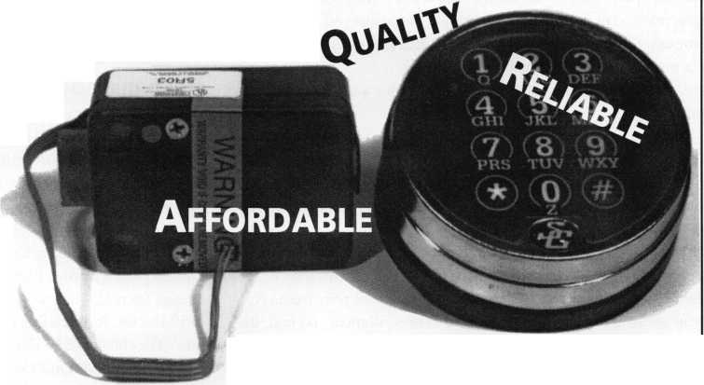

A motorized drill is a useful tool for a lot of different tasks. The drill motor could be AC or battery powered. As locksmiths, we have plenty of jobs that require the use of a drill motor. Whether the drilling is needed for hardware installation or to drill open an otherwise stubborn lock, we will sometimes put our drill bits through a beating. The majority of locksmiths probably just replace dull bits.

Depending on the number of dulled drill bits that you go through per year, tossing out old bits and buying new ones might be the most practical option for you. If you replace a lot of drill bits each year, the replacement cost for new drill bits might just make you consider some other options. Having your dulled drill bits re-sharpened might be a way to save some money. Your options here are to take your drill bits somewhere to have them sharpened, or attempt to sharpen them yourself.

Deciding to sharpen your own drill bits brings on a whole new set of options. You could just wing it and sharpen them by hand on an ordinary grinding wheel. If you try it without any types of fixture or guide, the results will probably depend on how good your hand and eye coordination stacks up. Your individual talent and knowledge of drill bit geometry will determine the quality or usability of drill bits that you sharpen by hand. If you go to special equipment, tools or devices, the products you find will probably range in price from very cheap to extremely expensive. The better the equipment you find, the greater likelihood that the cost will be higher. Like any other tools, you have to make a judgement as to what capability is sufficient for your needs, and what price is in your budget. Figuring out the volume and quality of work that you’ll need to generate (with the equipment) will help you determine what piece of equipment fills the bill.

Darex is a company in Oregon that manufactures a wide variety of drill sharpening machines. Darex Industrial Corp. makes somewhat large and fairly expensive drill sharpening equipment. The typical customer for those products is an industrial user of drill bits. If you are a small manufacturer, you might go through a large quantity of drill bits while manufacturing some product or products. If you need to sharpen a very high volume of drill bits, that class of sharpening equipment might be what you are looking for. That kind of equipment would be way out of range for the typical locksmith. Darex Professional Tool Corp. is another division of the company that also makes drill sharpening equipment, but aimed at customers with much more moderate drill bit sharpening needs.

THE DRILL DOCTOR

Darex Professional Tool Corp. makes two different versions of a drill bit sharpener called the “Drill Doctor.” Photo 1 shows the model 750SP Drill Doctor. It is a fairly compact precision drill bit sharpener. It can sharpen drill bits from 3/32 inch up to 3/4 inch diameter. The Drill Doctor will re-sharpen carbide, high speed steel, standard, masonry, split point, cobalt and parabolic twist drill bits. There are two chucks included to hold drill bits while sharpening. One chuck has a range from 3/32 inch to 1/2 inch, and the other has a range from 1/2 inch to 3/4 inch. Photo 2 shows the back of the Drill Doctor. A removable chuck holder is attached to the back of the unit. The chuck holder shown is included with the model 750SP.

The model 500SP Drill Doctor is nearly identical to the model 750SP The only noticeably different features are that the model 500SP includes only the smaller size chuck (3/32 inch to 1/2 inch range) and the chuck holder is not included.

Keynotes

November 1998

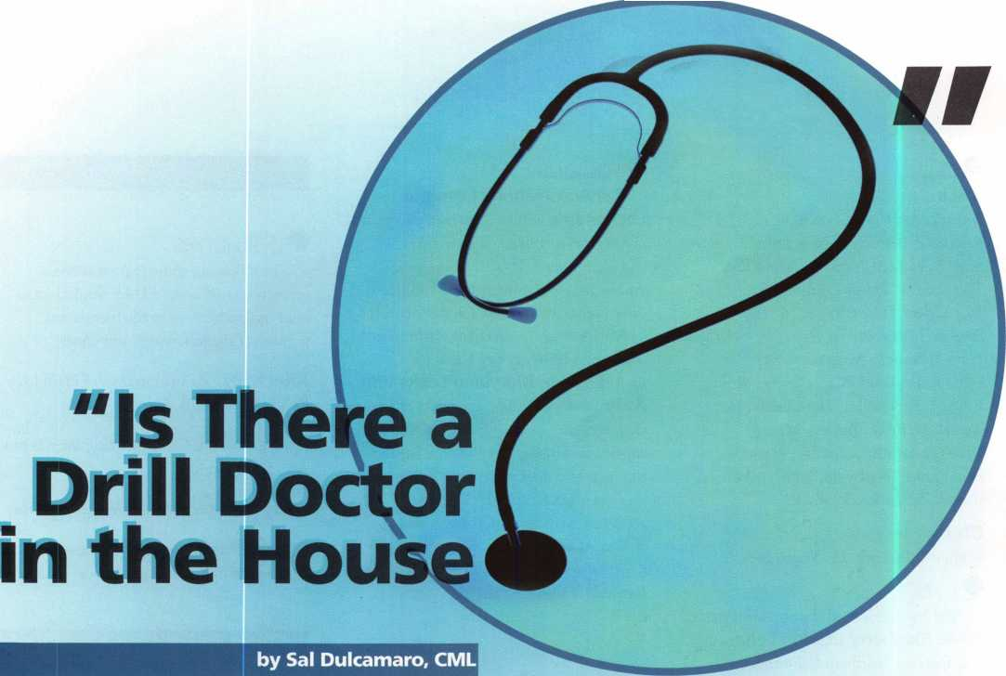

Before you sharpen a drill bit, you must know what point style is on your drill bit.

I’m not that knowledgeable about drill bits, so I’ll rely on the information I found in the instruction booklet. Apparently, the most common drill bits are standard 118 degree points, 135 degree split points and 135 degree masonry points. If you are not sure of the angle, there are guides on the front of the Drill Doctor that let you gage the angle yourself. Photo 3 shows the angle notches built into the unit near the top right. One is 118 degrees, and the other is 135 degrees. In photo 4,1 am using the angle notch to verify my drill bit angle. I quickly discovered it to be the standard 118 degree style.

The instructions suggest using a drill bit of 3/8 inch diameter or greater when first trying to use the Drill Doctor. The bit I used was just slightly under 3/8 inch and fairly easy to work with. I can attest that it is more awkward dealing with much smaller drill bits. I presume that as you use the unit more, you become more comfortable with the feel.

Once the angle has been determined, it is time to begin the sharpening procedure. Photo 5 shows the simplicity of design, with raised numbers located where different tasks are done. There is visual verification of all the instmctions and steps. The round opening in front is the alignment tube. The #2 can be seen just above the opening of the alignment tube. There is a handle and pointer to position it for the different style drill points. It is currently set for standard 118 degree. Just above that is for 135 degree split points and at the top is 135 degree masonry points. Just above the angle notches, a raised and encircled #3 can be seen. An arrow connected to it points to the side opening where the chuck is inserted for the sharpening step. The #4 at the top left of the unit points to another opening on the other side where you can split the points if your drill bit is that type.

The drill bit is loosely held in the chuck in photo 6, while the tip is inserted for alignment. Two spring loaded prongs grip the tip of the drill. You would rotate the drill bit until the prongs sort of close down on and grab it in the correct alignment position, as in photo 7. Two flats on the outside of the chuck cause it to be positioned properly within the alignment tube, and maintain the same alignment when inserting the chuck for either sharpening or splitting. There is a stop surface inside the alignment tube, and the drill bit should make contact with that surface before tightening it securely in the chuck. Photo 8 shows the chuck being tightened around the drill bit.

November 1998

Keynotes !_

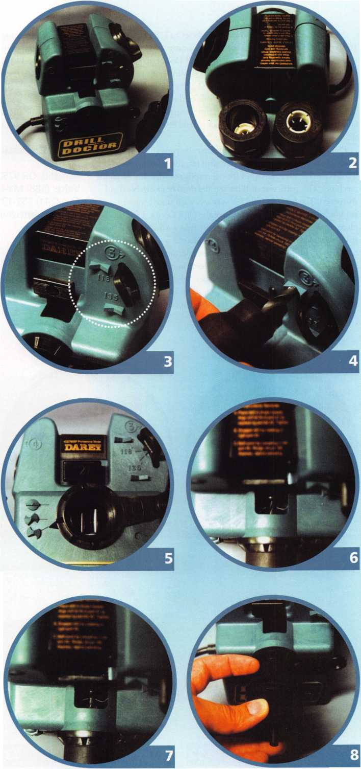

An indicator in photo 9 shows the angle set to 118 degrees. Photo 10 shows the tip of the drill bit before sharpening. It is somewhat nicked and dulled. After turning on the Drill Doctor, the chuck is inserted into the sharpening port (labeled #3), in photo 11. While firmly pushing in and down, as in photo 12, the chuck should be rotated clockwise. You should continue until the grinding sound gets quieter. It usually takes a dozen or more turns depending on the size of the drill. When you finish, the chuck should be removed from the sharpening port.

Photo 13 shows the tip of the drill after sharpening. It did a pretty good job. If it had been a split point drill bit, the splitting procedure would have been completed in the point split port (labeled #4 on the machine). This particular drill bit was the third or fourth bit that I sharpened. The first one I did felt very awkward since I wasn’t familiar with the fee] and operation of the Drill Doctor. I felt much more comfortable with it after a few more tries with other drill bits. I still had some trouble with much smaller diameter bits, especially in regard to the alignment process. I suppose additional practice would improve that too. Darex has a toll free phone number, so I suppose you could call them if you got stuck somewhere in the process.

Like any other piece of equipment, cleaning and maintenance will help to extend its life. Photo 14 shows the cover lifted to expose the

grinder wheel inside. Grinding dust can be brushed out of there and also the various ports. The wrench shown is used for removing the grinding wheel when it needs to be replaced. It should, however, sharpen quite a few drill bits before that will be necessary. The life of the grinding wheel will depend on not only the number of drill bits sharpened, but also the size. Larger drill bits will create greater wear. The model 300SP has a cost of $169 and the model 750SP costs $199. For additional information about the Drill Doctor, contact:

Darex Professional Tool Corporation

Box 730

Ashland, OR 97520

Voice: (888) MY-DRILL, (888 693-7455)

Fax: (541) 552-1377 Website: <http://www.drilldr.com>.

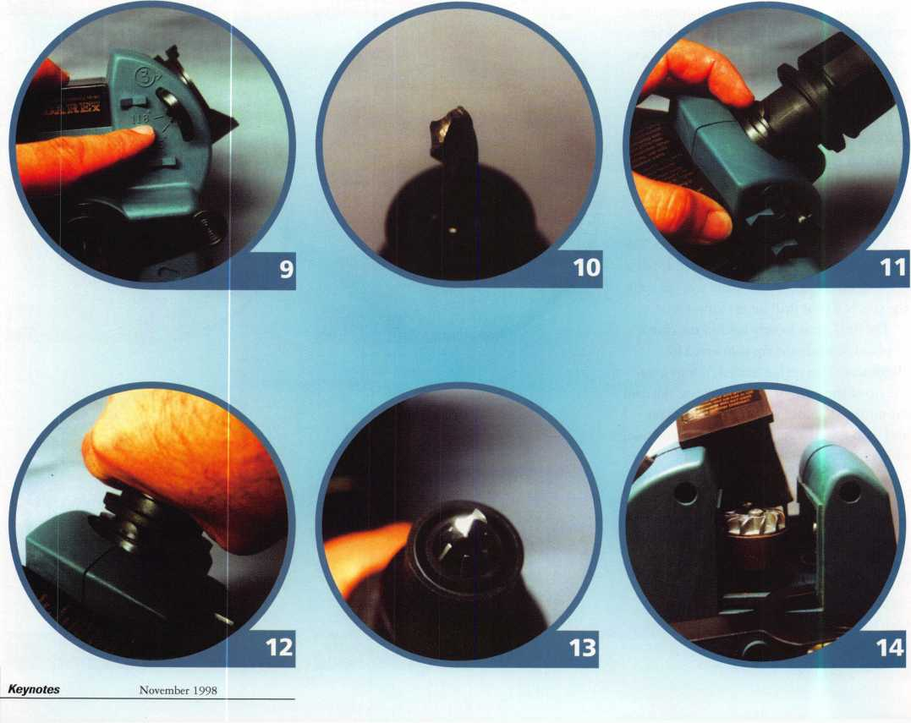

A Simple, but Effective Tool

to Solve a Major Problem By Steven B. Spiwak, CRL

Several years ago, I remember a survey that  
polled locksmiths across the country on the  
subject of business. The number one problem  
was not competition, product pricing or even  
the high cost of advertising, not that these  
items were not on the list in question. The  
number one problem for the professional  
locksmith was employee turnover.

It seemed that just as soon as you were  
able to effectively train someone to become a  
professional member of your staff, just as  
soon as this individual could go on a difficult  
service call and not need your help or have to  
return to the shop half a dozen times, just  
when he or she was actually starting to  
produce profit for the company, they would  
up and leave for any variety of reasons too

numerous to mention here.

Some of those reasons were very  
good reasons for leaving. Other reasons  
were just plain silly. In either case, the  
result was the same. Several months or  
several years of intensive often times  
heartbreaking training and education  
down the drain. Now some other  
employer would have the benefit of  
your hard work while you had to go  
through the arduous interviewing  
procedures that only lead to the  
months and years of painstaking  
education and training. What was an  
owner to do? Nowhere was this growth

process more evident than in the area of keys,  
key blanks and key way memorization. I  
have often felt that the most difficult and  
discouraging job in locksmithing was  
memorizing and mastering the thousands of  
keys, key blanks and key ways. Let’s face  
facts! If the person being trained for the  
locksmith position is not a machinist, then  
key blanks are just not like anything that  
anyone else is used to handling.

It wouldn’t be so bad if there were only a couple of dozen key blanks to memorize or even a couple of hundred key blanks to memorize over a reasonable period of time. However, the apprentice locksmith’s trial by fire starts the moment that he or she begins to service customers at the front counter.

Invariably, the first key that the novice faces is a 7 1/2 pin Yale sectional key followed by any number of esoteric and out- of-production numbers that soon reduces the would-be locksmith to tears.

There is however a solution to both the problems of turnover (which I will deal with in a future issue) and key blank identification (which I will deal with in this article). There is always the tried and true method of the tedious process of memorizing milling configurations and various sets of alpha­numeric coded numbering systems, but there is now available a most unique little tool that is ideal for the most experienced locksmith looking for a rare sectional key way for an out-of-production manufacturer to the most inexperienced novice locksmith trying to distinguish a Schlage 1 145C from an 1 145E.

The tool is called the KeyCheck, and it is available from PRO-LOK. This modest little tool is in actuality an ingenious little device

that will quickly and conveniently help the locksmith identify an infinite number of different key blanks.

This small device utilizes two series of minute bars or “stainless steel fingers” that run through the device in a horizontal fashion (see illustration).

STEP 1 —Pull each set of stainless steel fingers in opposite directions outward from the center of the blue milled aluminum body as far as they will go.

STEP 2 —Insert the unknown key blank into the opening created by the action performed in STEP 1.

STEP 3—Starting with the set of stainless steel fingers on the right side of the device, push each individual finger as far to the left as it will go. If this action is done properly the stainless steel fingers will bottom out against the key blank and key blank millings. At this point gently tighten the set screw on the right side in the back of the

device. DO NOT OVERTIGHTEN! This  
will secure the stainless steel fingers in their  
current position, which will create the right  
side of the key way (or broaching).

STEP 4—Starting with the set of stainless  
steel fingers on the left side of the device,  
push each individual finger as far to the right  
as it will go. If this action is done properly  
the stainless steel fingers will bottom out  
against the key blank and key blank  
millings. At this point, gently tighten the  
set screw on the left side in the back of the  
device. DO NOT OVERTIGHTEN! This  
will secure the stainless steel fingers in their  
current position, which will create the left  
side of the key way (or broaching). This  
action will complete the necessary steps  
needed to create the unknown key way.

STEP 5—Carefully insert the key  
blank which you believe to be correct  
(or at the very least an acceptable  
equivalent to the unknown key) into  
the KeyCheck device. DO NOT  
FORCE the key blank into the newly  
created key way! If the key blank that  
you have chosen does not fit, then you  
must find the correct key blank  
through trial and error, recognizing the  
correct key blank if and only if it can  
be inserted and removed easily from  
the key way that you have created  
using the KeyCheck.

STEP 6—Loosen the two retaining screws enough to be able to push both sets of stainless steel fingers on the right and on the left side of the KeyCheck inward toward the center of the device. Now pull each set of stainless steel fingers in opposite directions outward from the center of the blue milled aluminum body as far as they will go. Now you are ready to identify or verify the next key blank.

This durable little device makes key blank identification as painless as humanly possible!The KeyCheck is small and compact. It is easily held in your hand and can be conveniently carried in a shirt pocket or small tool box along with other essential locksmith-tools. KeyCheck is manufactured by PRO-LOK. For further information on the KeyCheck or their many other fine products, call (714) 633-0681 or write to PRO-LOK at 655 North Hariton Street, Orange, CA, 92868-1311.

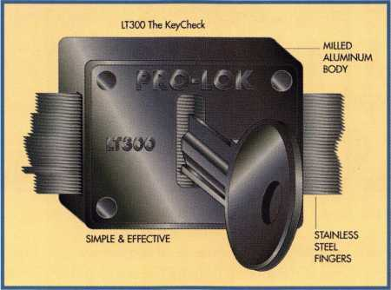

November 1998

Keynotes

by Sal Dulcamara, CML

Keedex is known for its weldable gate boxes, cylinder guards and other hardware products but it also produces a variety of interesting locksmith tools. Among these are some specialty screwdrivers that can be very useful when servicing locks. Both screw­drivers are designed for difficult-to-remove screws. In each of the two cases, however, difficult-to-remove has a much different meaning.

**The "Spin Out" Screwdriver for Mortise Cylinders**

Photo 1 shows the “Spin Out” screw­driver. This tool is designed primarily for difficult-to-remove cam screws, but may have other possible uses. The unit consists of a welded base and frame, with a bronze bearing to hold the screwdriver. Four sizes of interchangeable screwdriver bits are included. There are two with slotted tips and two for use with Phillips head screws.

“Difftcult-to-remove,” in this instance, indicates tightly driven (and sometimes secured by loctite) cam screws. The other

stumbling block is the small and awkward size of the mortise cylinder (from which the screws are to be removed), and the trouble of trying to remove the cam screws when holding the cylinder in one hand and the screwdriver in the other.

There are certain tasks, in locksmithing, that tend to cause an unexpected donation of blood. I’m not talking about a sudden visit to the blood bank in the middle of the day. Some jobs just have a nasty habit of making me (accidentally) poke myself with a rather sharp object. Removing cam screws fits into that category. Trying to apply enough force and torque (with the screwdriver tip against the cam screw), I will sometimes slip and push the screwdriver tip into my hand and end up bleeding all over. Many of you have probably had similar experiences.

I’m always open to tools that will help me avoid needless pain and suffering while on the job, and accidental self mutilation is never a welcome occurrence to my work day. The “Spin Out” screwdriver seems to be an

effective deterrent to needless bloodshed. The screwdriver component is being lifted out of the brass bushing in photo 2. The oversized handle is designed to provide a solid grip when tightening or loosening cam screws. Screwdrivers, with small enough tips for the cam screws, often have narrow diameter handles and make it difficult to generate much torque.

Photo 3 shows the opening for inserting the screwdriver tip. There is a magnetic insert inside that securely holds the tip in the screwdriver handle, and also magnetizes the screwdriver tip. The Phillips head screw­driver tip has been placed inside the unit in photo 4. The screwdriver component is ready to go back into the “Spin Out” stand.

A glued-on rubber pad is part of the base of the screwdriver stand. A mortise cylinder has been placed on that pad in photo 5, with the cam screw approximately in line with the screwdriver tip. As the screwdriver shaft is lowered through the brass bushing, the mortise cylinder can be more precisely

November 1998

20 I ***Keynotes***

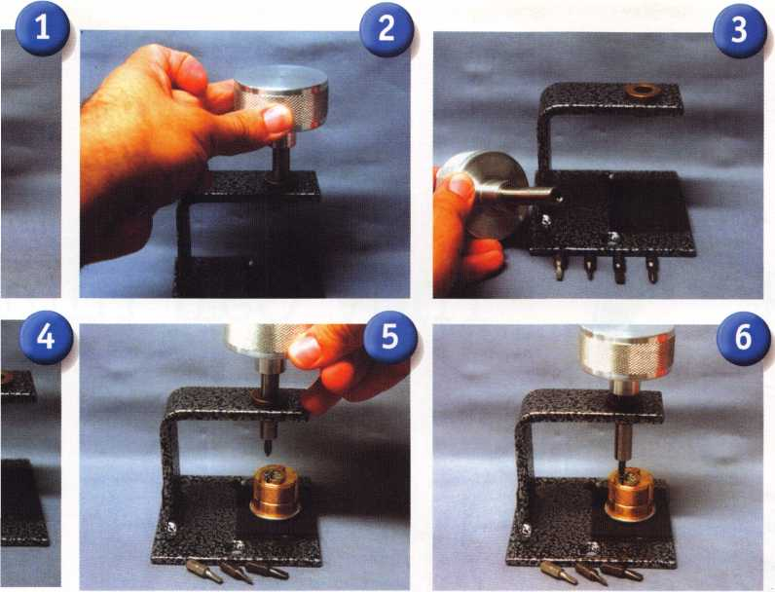

positioned so that the screwdriver tip will land in the center of the cam screw. The tip is solidly seated in photo 6. In this position, considerable downward force can be applied during rotation of the handle without the likelihood of losing control.

The correct application of torque should allow relatively easy removal of the cam screw without damage to the screw head. It will also be more effective on previously damaged screw heads, than a standard screw­driver. The brass bushing maintains control of the screwdriver shaft, while the rubber head grips the face of the mortise cylinder. This device makes cam screw removal almost effortless, and it doesn’t require a donation of blood.

**Tamper Resistant Screwdriver**

Keedex makes another screwdriver for different types of difficult-to-remove screws. The “Spin Out” is designed for tight or (for the most part) unintentionally difficult screws. There is another class of screws that are difficult-to-remove by design. There are

generally called tamper resistant screws, and they have screw head profiles that are designed to be highly resistant to operation by commonly available styles of screwdrivers (or screwdriver tips).

The Tamper Resistant Screwdriver is shown in photo 7. It includes a total of eleven tips, that store in the handle of the screwdriver. Included in that eleven are: six tamper resistant torx tips, three tamper resistant hex tips and two spanner tips. They come in the following sizes, and are beneath the screwdriver handle in the photo, arranged from right to left. Tamper resistant torx tips: T10, T15, T20, T25, T27 and T30. Tamper resistant hex tips: 5/32", 3/16" and 7/32". Spanner tips: #6 and #8.

Photo 8 shows the open end of the screw­driver handle. All the tips will fit inside the handle for storage. The end cap snaps shut to hold them securely and keep them from falling out of the screwdriver handle during use or when put away.

Like the “Spin Out” screwdriver, this one

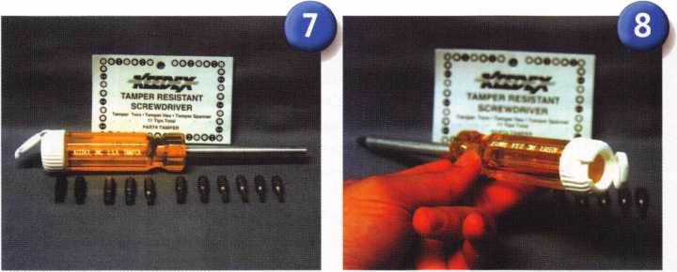

also has a magnetic insert inside the shaft of the screwdriver where the tips are inserted. One of the tamper resistant torx tips has been inserted in photo 9. What distinguishes this screwdriver tip from just a standard torx tip is the drilled hole in the center of the screwdriver tip. A tamper resistant torx screw has essentially a standard torx screw head with a raised pin in the center of the screw head opening. A standard torx tip would hit the pin in the center and not enter the screw head. The drilled hole in the proper tip allows the tip to fit over the raised pin and drive the screw.

The tamper resistant hex tips work on the same principle. A raised pin in the center of a tamper resistant hex head screw would keep out the ordinary Allen wrench (or hex key). The drilled hole in the center of tamper resistant hex tip would allow it to seat in the head of the screw and allow tightening or loosening.

Spanner screws have two small diameter holes side by side in the screw heads. The spanner tips have round raised spots side by side, that fit inside those holes in the heads of the spanner screws. The Keedex product brochure indicates that spanner screws are often used in commercial and institutional locksmithing work. Tamper resistant hex head screws are used in access control, and tamper resistant torx screws are listed as used in automotive work. There are no absolute rules as to when or where you will run into any of the specific tamper resistant screws, but it pays to be prepared for any circumstance.

Keedex products are available through many locksmith supply companies around the country. If your supplier doesn’t stock Keedex or if you wish to find out more infor­mation about these or other Keedex products, contact: Keedex, Inc., 12931 Shackelford Lane, Garden Grove, CA 92841- 5108. Phone: 714/636-5657. FAX: 714/636-5680. E-mail: [info@keedex.com](mailto:info@keedex.com). Web page: <http://www.keedex.com>.

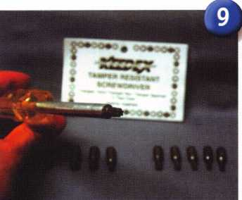

November 1998

Keynotes 121

They Call Him

WM to say a few words sa-w

good Mend and mentor, Hal Tidbits. I would have not received my ACE award from ALOA were it not for Hal. Over the SO plus years that I have known Hal, he has inspired me to a provide a high level of profes­sionalism in the classroom as well as in my business. Congratulations to Hal for receiving this award, which is very deserved.

**- Bob Lawrence, CML**

When you meet Harold “Hal” Tibbits, it’s  
easy to detect his sense of modesty. So humble is  
this year’s recipient of the A.L.O.A. (ALOA  
Lifetime of Outstanding Achievement) Award,  
he didn’t even show up for the awards banquet  
at ALOA ’98 in Nashville.

“I think there’s a lot of people who deserve  
this award, but I sure didn’t think I was one of  
’em,” says the 67-year-old Tibbits from his  
home in San Diego, Calif. “The day after  
the banquet, I found out I won it and was  
disappointed that I didn’t go. I had no idea that  
I was up for any award. It really surprised me.”  
Hal’s history in locksmithing extends back over  
two decades and his membership with ALOA is  
approaching its 30th anniversary next year.

Originally hailing from Schenectady, NY,

Hal grew up the son of Irving and Hilda  
Tibbits. At age 17, he enlisted in the United  
States Navy where he would serve for 23 years.  
Electronics was his forte in the Navy and  
although much of his time was spent stationed  
domestically, he saw action in Vietnam.

He says that his fondest memories were on the U.S.S. Turner Joy where he learned some of life’s more important lessons.

“I learned self-discipline and how to get along with people,” he says. “I really enjoyed it. It was a good time in my life. I don’t think I could do over again, but I wouldn’t trade those years for anything now.”

As his naval years came to an end, Hal had grown tired of electronics and wanted to learn a trade that dealt with more tangible elements. During his final three months of service, Hal was involved in a program where Navy personnel could seek civilian employment and make a decision about their future careers.

Locksmithing seemed to be a perfect fit for him as he felt more comfortable working with the more visible lock mechanisms.

d

22 | Keynotes

November 1998



Mister Tibbits

(but you can call him Hal)

By Mike Emery

“Locksmithing gave me something to work with that I could see,” he says. “With electronics, you couldn’t tell where those electrons were. And locksmithing, at that time, let me see the locks, the tumblers and the mechanical parts.”

Hal was confident that his skills as a locksmith were up to par, so with the aid of his devoted wife, Bobbi, he started his own business, Hal’s Mobile Locksmith Service, in 1973. For the next 23 years, he would provide service to the city of San Diego. While he went about his daily tasks, going out on service calls and such, Bobbi helped balance the books and other administrative tasks.

“Running a mobile shop was very enjoyable for me,” he says. “It didn’t have the overhead of a store. I made my mobile service strictly for commercial work, which was nice. I didn’t have to get up in the middle of the night and open car doors or any of that kind of stuff.

“Another benefit was working with Bobbi. We both learned to be very tolerant of each other when necessary and how to separate business from home life, which made working together a good experience.”

Due to medical reasons, he retired from locksmithing in 1993 (he says, however, that those problems are behind him), but remained active in ALOA and its San Diego chapter. He also continued contributing to the association as an instructor, as he had done since 1984. The two subjects he specializes in are “Master Keying” and ALOA’s “Instructor Training Program” (which he was instrumental in developing). He is also always ready to critique other instructors to help ALOA’s education program.

“If you enjoy teaching and enjoy your subject matter, there’s nothing hard about being an instructor,” he says. “It should come natural to you. I had taken a few years off from teaching, so I had to get back in the swing of things.”

He says that after taking his fair share of courses and after seeing a cross-section of different instructors over the years, he got an idea of how a class was supposed to be taught. With that, his “Instructor Training” expertise has been a welcome factor to ALOA classes.

“There were people out there who really knew the subject matter, but didn’t know how to get it across,” he says. “Then there were people who spent more time telling you sea stories than putting out the information. So I wanted to get involved to help teach people how to properly instruct a class, and help students get what they paid for.”

In other accomplishments, Hal was a key figure in creating the Locksmith-Contractor License within the state of California, which became active Aug. 1, 1996.

“The other states were having trouble keeping locksmiths out of electrical work and that kind of stuff,” he says. “We wanted a separate number for locksmiths so, by state law, we could continue doing access control, electric strikes and all the stuff that some other states have pushed locksmiths out of.”

These days, Hal is happily retired in the beautiful city of San Diego where he lives with wife Bobbi and nameless pet cockatiel. “We just call it ‘Bird’,” he says.

He and Bobbi have four grown children, Linda, Buddy, Pat and Cathy, all whom are no doubt proud of their father’s accomplish­ments in locksmithing and as a member of ALOA.

When they’re not enjoying the pleasant climate of San Diego, Hal and Bobbi spend their days seeing the country. Aside from making the trip down to Nashville for ALOA ’98, Hal says one of their most recent travels took them to another country music haven, Branson, Mo., which they both found to be quite enjoyable.

Although he was an unassuming recipient the 1998 A.L.O.A. Award (which he refers to as his “Oscar”), he still has high expectations of the association he has contributed to for so long. Fortunately, since joining he has been consistently pleased with ALOA’s benefits and is a staunch supporter of its educational programs and advancements.

“I’ve always enjoyed the educational aspects of the association,” he says. “That and talking to the other locksmiths at the conventions and sharing information whether it’s business or technical. Plus, Keynotes gives the members helpful information. But aside from its strong educational benefits, ALOA gets locksmiths together and gives them a code of ethics to live and work by, which is one reason I’ve been pleased to be a part of it.”

November 1998

***Keynotes*** 1^

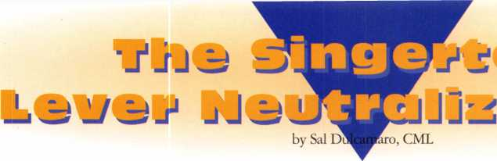

When you get called to a lockout, the most common tactical options for a locksmith are either picking or impres- sioning. Whenever possible, a professional locksmith will avoid opening techniques that may damage a lock cylinder or lockset itself. A third non-destructive option is some form of bypass. The implication of bypass is that you are going around the lock cylinder and finding some flaw or weakness in the basic security of the lockset itself.

In some cases, bypass can be used as a first line of attack. It can also be used as a secondary or alternative option, especially when you are having no success at all with picking or impressioning. A bypass method can take many different forms, depending on the lock and door in question. An interesting new device called the Singertech Lever Neutralizer Tool provides a new bypass option for lever handle locksets. In photo 1, the two components of the device can be seen in their carrying case.

Photo 2 shows the Lever Neutralizer Retainer Press (LNRP-1). This component of the tool is designed to force the lever handle retainer inward, in order to remove the handle from the lockset with the assistance of the other component. The LNRP-1 is placed around the neck of the lock handle in photo 3. What seems to be a hardened pin is positioned inside the retainer hole. The retainer, backed up by the tailpiece of the lock cylinder, will tend to resist going inward enough to release the handle.

Without sufficient force, the pin will only go so far. With the device wrapped around the neck of the handle in photo 4, tightening the knurled knob clamps the device closer together. The hardened pin pushes inward on the retainer, until the pin will go no further. The handle is ready to be removed. The other component, the Lever Neutralizer Puller (LNP-1) will be used to pull the handle.

I suppose that the lever handle could be pulled out manually, now that the retainer has been forced inward by the hardened pin of the LNRP-1. Damage might occur if the lever handle is not pulled straight outward, so the puller component is designed to prevent the handle from tilting during the pulling motion. The LNP-1 is shown in photo 5. The long bar on the right side will

A Keynotes November 1998

fit over the back surface of the lever handle, and the steel pin will set just to the side of the lever handle on the retainer side. The machine screw attached to the turn handle will press into the face of the lock cylinder, as the screw is turned clockwise to pull the lever handle backwards and over the depressed retainer.

Photo 6 shows an Allen wrench in the head of one of the four thickness adjustment screws. They can be adjusted for different lever handle styles. For some curved handles, it may be necessary to adjust the outbound screw further than the closer to the neck of the handle. That would allow the tool to apply pressure more evenly as the handle is pulled outward, parallel to the surface of the door.

The LNP-1 has been placed over the lever handle in photo 7. The knob on the screw is turned clockwise, in photo 8, until the lever handle is pulled far enough to clear the retainer. Photo 9 shows a side view of the action, with the lever handle pulled clear of the retainer. The Lever Neutralizer Retainer Press (LNRP-1) stays with the lever handle as the handle is pulled with the LNP-1. When the handle moves a short distance, the hardened pin holding the retainer downward will slip off the retainer. At the point, however, the handle will be released and the retainer will pop back out. The lever handle has been removed in photo 10. You may notice that the lock cylinder remains, since the tool used the face of the plug to push off and pull the lever handle. The cylinder can now be removed for whatever servicing is required.

The After Effects

The instructions that come with the tool indicate that the LNRP-1 and LNP-1 are not designed for repeated use on the same lockset. The tool is designed as a non­destructive bypass tool. Repeated use could cause permanent damage to the retainer mechanism, and make it likely that the



j



handle would come off under normal circumstances. It should not be used with Corbin Russwin levers, as the instruction sheet indicates likely damage to the retainer.

The lock on which I tested the tool was a Schlage AL (Grade 2) series lever handle lock. It will work equally well on the Schlage (Grade 1) Rhodes lever, as with most other lever handle locksets. I only used the tool one time on the lock, and there was no apparent damage. The retainer worked fine afterward. Photo 11 shows and extreme close up view of the retainer. A mark can be clearly seen where the hardened pin pressed into the retainer. Looking inside the cavity where the lock cylinder was removed, photo 12 shows a different view of the retainer. The retainer piece has a general resemblance to an “E” clip. The center leg of the letter “E” is the surface that normally makes contact with the tail piece of the lock cylinder. There appears to be stress marks in the curves just above and below that leg. I presume that the tool applied the greatest pressure at those two points. Nothing appears to be broken.

This is an impressive tool. It can be quite effective and valuable when dealing with lockouts, especially for tough to pick lock cylinders or when going against a high security cylinder. As security professionals, we must now consider the vulnerability of both lever and knob locksets that retain handles in this manner. Although this particular tool works very well, it is not beyond possibility that the basic bypass technique could be accomplished without this specific brand tool.

This method of entry provides minimal external evidence of compromise. This could prove troubling from an insurance standpoint for a customer that has a high security cylinder in the lockset and picking was not considered a legitimate possibility as a means of compromise. Make note of the concealed markings (on the retainer) that I indicated were signs of this method of bypass being used. It could be useful knowledge for providing forensic evidence for a client.

For additional information about the Singertech Lever Neutralizer Tool, contact: Singertech, 1923 Verne Roberts Circle, Antioch, CA 94509-7910; (925)777-0401; (925)625-6130 fax.

S1NGERTECR

PAVPOffl SH 000\9i

LHP-1

November 1998

Keynotes

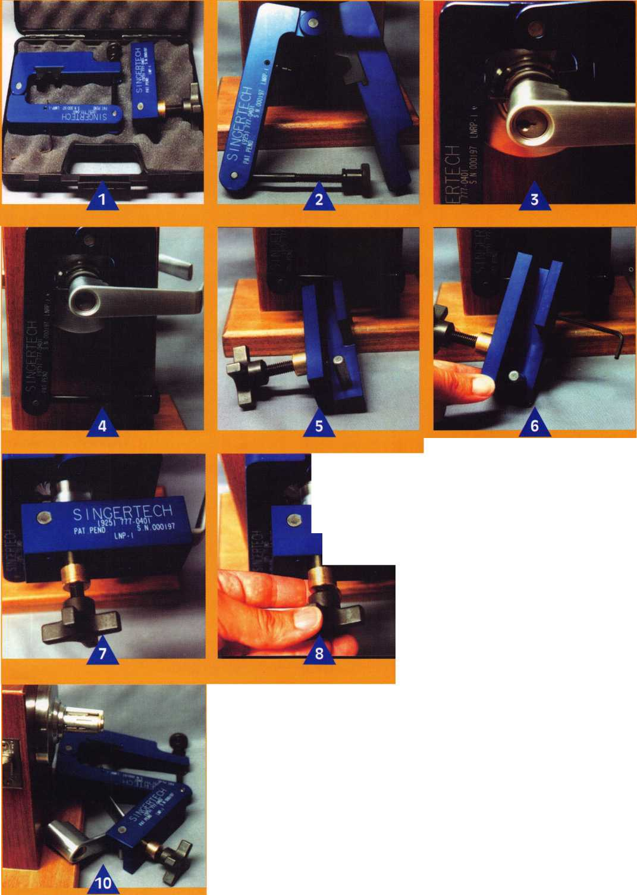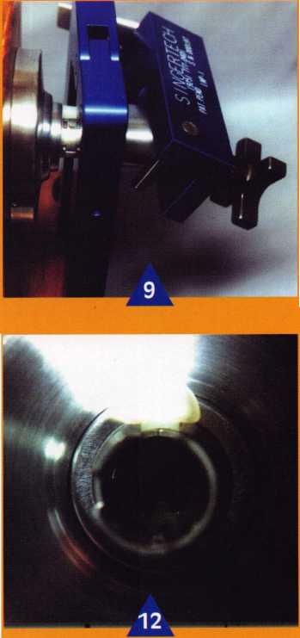

Twelve years ago, while working for a major lock wholesaler, I received a call from a very good customer. He wanted electrified panic hardware for four double doors and six single doors. Like most good salespeople, I recommended what I felt would be the best hardware for the application. I selected Von Duprin EL99 rim devices for the single doors and EL9947 concealed vertical rods for the double doors; not only does this hardware look good, but it maintains the “concealed” look. This is great hardware in most applica­tions, but there can be problems with the concealed vertical rods. Little did I know that a few years later I would go to work for this customer and be cursed with servicing these double doors. I say cursed because for the next seven years I tried many different “fixes” for a poor choice on my part.

Let me explain some of the problems and the fixes I made prior to what I hope is my final repair, and what should have been done in the first place. The first problem I ran into was related to the original door and hardware installation and the wind. Ridgecrest is in the Mojave desert of California and gets very windy at times. The original doors were

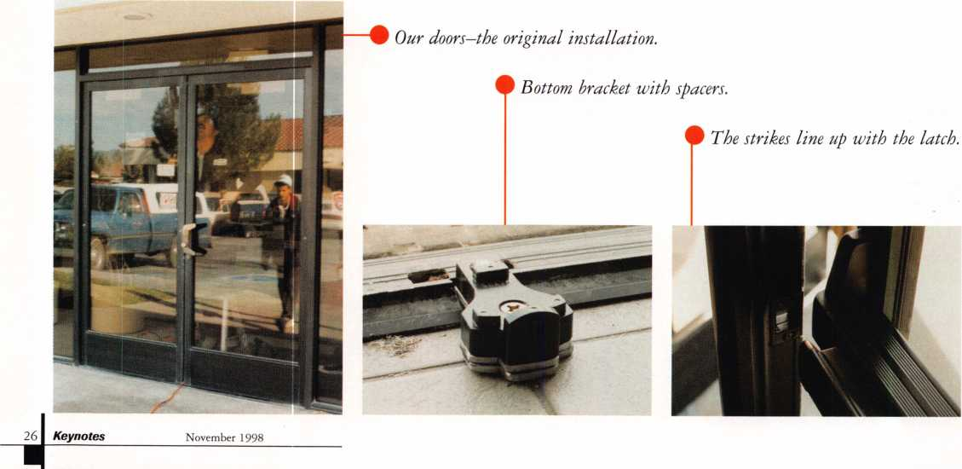

installed center hung with Jackson concealed overhead closers and Adams Rite locks. When our technician installed the Von Duprin 9947s he put stops on the tops of the doors but not at the bottoms. The wind would slam the doors shut past the bottom strike jamming the hardware. This was solved with the installation of a latch-track threshold. The next problem I needed to correct was the failure of the Jackson closers to latch the doors. This is due to the design of the closers. There is no preload or spring pressure to push the doors closed the last 10 degrees. Instead they use a cam assembly that wears over time, allowing the doors to float. I replaced the closers about once a year until I removed the springs of the closer and surface mounted LCN 4041 closers on drop plates. This solved most of the problems for awhile; however I still had to go out occasionally and adjust the rods and lube the latches. Finally the center cases started giving us trouble. This brings me to the final fix. I hope.

I convinced the customer to install removable mullions and replace the center cases with rim cases. We (I had help) started by installing the bottom mount. This needed

to have a 1/2" spacer placed under it to position the strikes at the correct height (photos two & three). Next, the upper mount is installed and required an extra bracket (photos four & five). Since the doors are center hung, there is not enough material on the header to support the bracket. We fabricated a bracket out of 1/4" 2" X 3" angle iron painted to match. We then cut the mullion to length and installed it. The doors were removed and the vertical rods removed along with the center case assembles. The new rim center cases were installed and the doors reinstalled. We checked the operation of the doors and adjusted the closer speeds; everything worked perfectly. Well, almost. I had to go back the next day since I forgot to adjust the shaft of the outside trim to the new center case.

The new center cases and the mullions were installed on the first set of doors about three years ago. The second set was installed about three months ago, which is when I took these pictures. The customer is very happy with the result.

Hindsight, they say is 20/20. In this case, 20/20 hindsight means I as the wholesaler

should have specified mullions and rim devices to begin with. I tried to maintain a look instead of a function. As a hardware supplier I look at most jobs with the eye of an artist—let’s make it look good and worry about function later. As an installer and locksmith, I’ve learned that maintenance should come first, looks second.

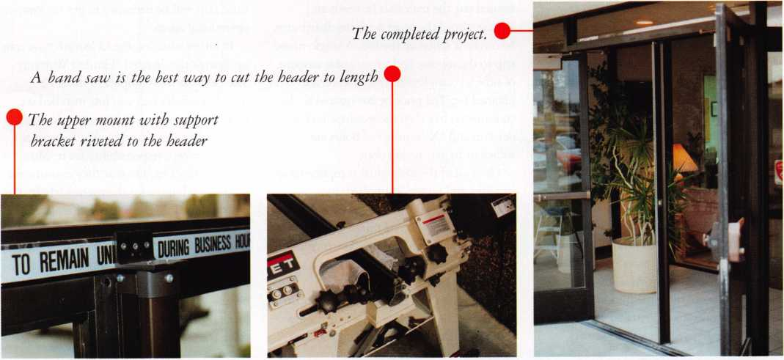

November 1998

Keynotes

Imagine how much more fun (and more profitable) your business would be if you never, ever had to deal with another product that had a manufacturer’s defect. No more call-backs! No more multiple trips to the job site! No more irritated, and irritating, customers who don’t really want to hear that the problem is out of your control!

But we’re all reasonable people. We recognize the fact that imperfect people and imperfect technology will occasionally conspire to put an imperfect product in our hands. Intellectually, we accept this fact of life. Emotionally, though, it is difficult to not take it as a personal affront when somebody else’s screw-up spoils our day, or worse.

Mass retailers haven’t made life any easier for the installing dealer of security hardware. Consumers have been trained to expect instant satisfaction when they find anything wrong with the products they buy. In fact, many retailers let you return items for no particular reason at all (even after you’ve used them) for instant credit. This has created an almost impossible standard of customer satis­faction for our industry to cope with. No doubt this also influences our reaction to less- than-friendly warranty policies that we encounter.

From my perspective, as a distributor dealing almost exclusively with electronic security components, I confront the complexities of manufacturer warranty policies nearly every day. As a “middle man,” I find myself caught in the middle when the locksmith dealer and the maker of a product don’t see eye-to-eye. Electronic security

28 | Keynotes

November 1998

products pose more problems than mechanical hardware for a number of reasons. The products are more complex, so there is more to go wrong. They are also more likely to be damaged by incorrect installation.

Since they are usually installed in systems comprised of several distinct components it is often difficult to isolate where the problem really lies. Add to this the fact that these are relatively expensive items that nobody wants to take a loss on.

All of us, manufacturers, distributors and dealers, need to see these issues from the other guy’s perspective. We need to “walk in the other man’s moccasins for a mile.”

...Let's start with the locKsmith. Having

figured out the materials he needs and having placed the order with his distributor, he can now schedule the job. A single round trip to the job site and a reasonable amount of time to complete the installation are planned for. The price he has quoted to the consumer is based on the assumption that one trip and “X” number of hours are sufficient to get the job done.

Once all of the individual components are installed and power is supplied, the locksmith discovers that the system does not work. Why not? Have I mixed up the wires? Have I programmed the unit correctly? Did I order compatible components? Or is one piece of the puzzle just plain bad?

Frequently, it takes hours of trouble-shooting to identify the product that is faulty. Now another unit must be ordered and another

trip to the job site is required. Temporary security measures may be necessary in the interim. An explanation and an apology must be given to the customer.

In another scenario, the system comes on line and seems to be working just fine.

Maybe it works for a week or more. Then Mr. Locksmith gets the dreaded phone call. “Our door won’t lock,” “we’re locked out” or “we’re locked in,” the agitated customer announces. Hurry to the job site. Test everything that might be wrong. Isolate the problem. Find out that the “whosiwutsis” has failed. Sure, it’s still in the warranty period, but that doesn’t solve the immediate problem. Temporary measures must be undertaken and a replacement must be obtained. Once the replacement comes in, a third trip will be necessary to get the system operational again.

In either situation the locksmith now runs up against the dreaded “Limited Warranty.” The fact that this component has a 12- month warranty and you just installed it a month, or a week or an hour ago, does not necessarily mean that the manufacturer is going to accept responsibility for it. Most manufacturers require that they examine the product and judge for themselves whether or not they are obliged to repair or replace it. They may decide that it was damaged by the installer, by vandalism, by weather, power or other conditions beyond their control. They may decree that it is in fact out of warranty because, although it has been installed for just a short time, the 12-month warranty clock started ticking the day they made it

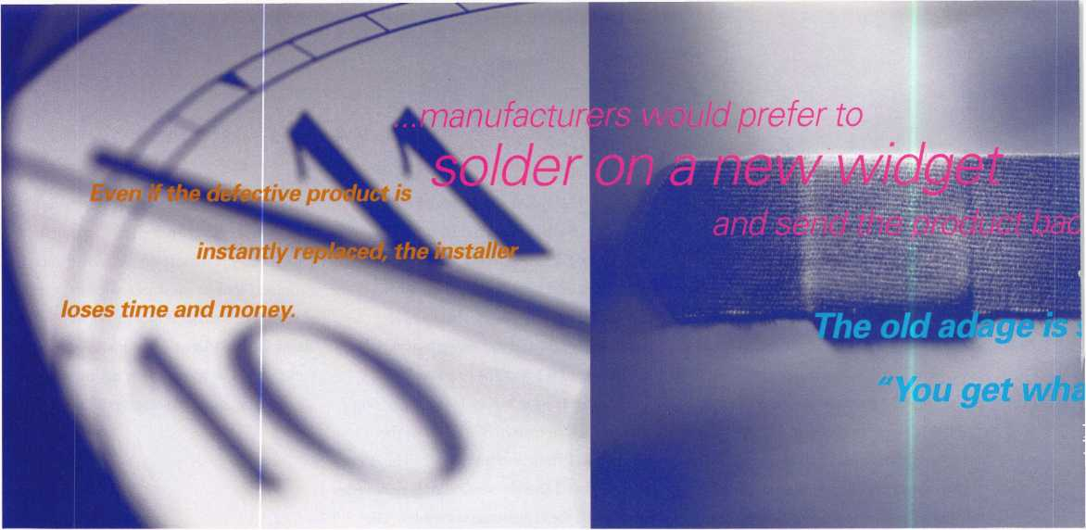

|  |  |
| --- | --- |
|  | jf  ."Safe <■  HH^ : 'k  m j«i Ibmpl |
| reading the  '"Fir | III Hh| | |  IP |
| J Milf P | 1C  ri n\n |
| r | | 1 1 | L. By Paul F. Chandler, CRL |
|  | of responsibility  in Limited Warranties |

and slapped a “date-code” sticker on it. Or they might “bench test” the item and it seems to be working okay to them. (A variation of “Murphy’s Law” says that electronic products NEVER malfunction in the presence of factory technicians.)

In the meanwhile, during the days or weeks that it takes for the defective item to travel to the factory and for Technical Support to get around to testing it what does the locksmith have to do? He has to get the customer’s place secure again. This means that either a new component has to be obtained or a loaner unit has to be installed until the original is repaired or replaced. (Of course, installing a loaner unit and then later replacing it with the repaired original means an additional unpaid service call, doesn’t it?)

Even if the defective product is instantly replaced, the installer loses time and money.

Although the defective product was made by a manufacturer, and even though the warranty is issued by this manufacturer, most locksmiths look to their distributor to handle the replacement of the faulty item. The general expectation is that the distributor will simply replace the bad unit with a good one, no questions asked. You know, just like they do at WalMart.

Most .distributors would like nothing

00 L L© Tthan to make the locksmith happy by taking back the non-functional unit and handing them a shiny new one. Like most people, distributors like to be “nice guys” and they make their living by

maintaining the locksmith’s goodwill. Putting himself in his customer’s shoes he understands that a working component is needed and needed now. Let us suppose that the distributor takes the part back for full credit or an even exchange. What then?

Now it is the distributor’s turn to confront the dreaded “Limited Warranty.” First, the distributor calls the manufacturer to get permission to send the item back, usually called an “RGA” or “RMA.” This is not an assurance that the manufacturer will make the product like new. As we have already discussed, manufacturer warranties always leave them with a lot of discretion about what is and is not covered. When they decide that a product isn’t covered by their warranty, the distributor who has already given his customer a replacement item is left “holding the bag.” Even when they do accept responsibility for the defect they now have the option of issuing a credit (which they almost never do), replacing the bad unit with a brand new one or repairing the original item. Whenever they can, manufac­turers would prefer to solder on a new widget and send the product back. Sometimes they decide that nothing is really wrong in the first place, so they send the now-used item back. In both of these scenarios, the distrib­utor comes into possession of used merchan­dise. I don’t know any distributors in this industry who want to sell used access control components, or any locksmiths who want to buy them.

Distributors don’t like defective merchan­dise any more than installers do. Handling

customer returns is an expensive part of doing business, costing manpower and shipping expense. Inventory dollars tied up in defective goods cannot be used to stock shelves with sellable items. Add to this the loss the distributor suffers when a manufac­turer declines to issue credit, or sends him back a used and unsellable product, and you have a major source of loss that has to be offset with higher prices or reduced services.

So what are we saying? That manufac­turers are the bad guys? Not necessarily.

Put  
the s

manuiduiui t?i . He employs

technical writers to prepare careful and detailed instructions for his products. He provides customer service technicians on toll- free phone lines to help installers and end users. And still, some people butcher his products. He employs skilled technicians whose sole responsibility is to check out product defects and determine the source of the problems. Some of the returned goods have clear defects in the manufacturing process or faulty component parts. The manufacturer accepts responsibility for these. Others have obviously been damaged in the field. Still, others appear to be working just fine. Is the manufacturer responsible for replacing, at his expense, every item that anybody chooses to return to him?

If he wants to sell his goods to WalMart, he has to accept that responsibility. That is part of the deal and you either like it or lump it. Unfortunately, neither the individual

November 1998

Keynotes

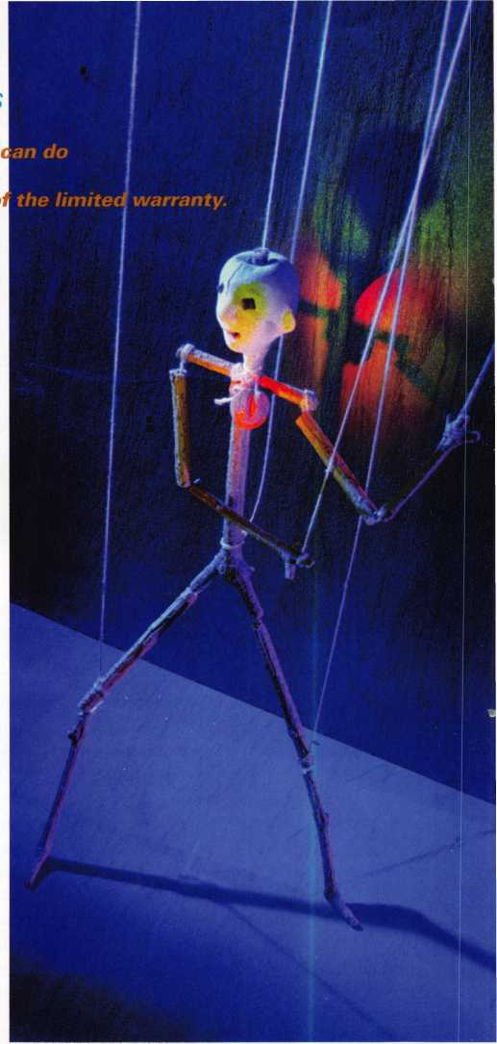

*of course, this does not mean*

*that locksmiths and distributors are helpless pawns. There are things we*

***to avoid being victims o***

locksmith nor the security products distrib­utor has the clout of Sam Walton & Co.

Manufacturers of electronic security products, by and large, reserve the right to evaluate returned goods and make the deter­mination of what, if anything, is wrong with them. At times, their decision will seem arbitrary or unfair to the distributor and dealer involved.

Of course, this does not mean that locksmiths and distributors are helpless pawns. There are things we can do to avoid being victims of the limited warranty.

First of all, recognize that access control, closed-circuit television, alarms and other electronic security systems require expertise that you may not currently have. Continuous education is required to stay up-to-date. ALOA offers classes in basic electricity and access control throughout the year. Many manufacturers offer product-specific training, often in conjunction with local associations or distributors. Some manufacturers and distributors have people who can consult with you on a specific application before you get started.

Many installers have learned the benefits of bench testing a system before installing the components in the field. This allows you to identify faulty components before you actually install them on site. Testing the system under “laboratory conditions” makes it much easier to isolate the defective product and reduces the possibility of the problem being an installer error. The system that worked well in your shop the night before will probably work okay after you’ve installed it today, reducing the likelihood of expensive callbacks and temporary solutions.

When you do run into trouble it is usually best to call the technical support people at the factory before you tear out the offending item. Many times these technicians can suggest a way to correct the problem in the field. If you try their suggestions and the system still won’t work they will often suggest the best way to go about getting a replacement. Always write down the name of any factory technicians you’ve spoken to and what they’ve told you. This information

makes it much easier to process a  
warranty claim later.

Understanding the policies and  
procedures of the product manufac-  
turer can mean the difference  
between taking a loss and getting  
satisfaction. For example, some  
manufacturers will provide an  
“advance replacement” if you ask  
for it. This means that they will  
ship a replacement item directly to  
the installing dealer. This might be  
a reconditioned unit or a brand new  
one. When the supposed defective  
item is returned to the manufac-  
turer they determine whether it is  
or isn’t covered. If not the dealer  
(usually through his distributor) is  
responsible for any costs.

Advance replacement can be a  
way to get an end user up and  
running without having to shell  
out a lot more money up front.

Sometimes the decision to deny  
a warranty claim is made by a  
relatively low level employee. Satis-  
faction can sometimes be obtained  
by speaking to the manufacturer’s  
representative in your region or to  
someone higher up at the factory. I  
am not advocating that you waste  
your valuable time in a shouting  
match. On the other hand, it is

often true that “the squeaking wheel gets the  
grease.” It is also often true that the people  
responsible for sales are more accommo-  
dating than the “techies” who spend their  
days in the returned goods dungeon testing  
products.

Your distributor may be able to tweak the system for you, but I have found that the installing dealer who knows the problem intimately is usually better able to make his own case.

Finally, we have the option that everyone has in a free market. We can choose not to buy. Manufacturers whose products frequently fail or who refuse to stand behind them don’t deserve our support. There are lots of electronic security products out there.

Competition is fierce. The manufacturers are competing on price and they’re competing on features. Let’s see them compete on quality and warranty, too.

The old adage is still true, “You get what you pay for.” Locksmiths and distributors need to sell quality and dependability. The end users of access control systems are often being sold no-name, commodity grade products when they would gladly pay a little more for something that will do a better job. In the name of using “cheaper” products, the installer often loses all of his profit in costly call-backs and unpaid warranty claims. It is up to us to educate our customers about the products we sell and to build a market for quality.

Keynotes

November 1998

As a professional locksmith, do you really want to know what your customers think about your product line and service? If you are sincere about knowing how customers perceive your business, don’t limit feedback gathering to an annual written survey Instead, recog­nize that feedback gathering is an ongoing and continual process that takes many forms. Almost all customer contacts offer some opportunities to obtain feedback. So, when and how should you gather customer feedback? Here are some possibilities.

Customer Feedback

by Claire Cohen, CNIL

A NEW CUSTOMER-

GATHER INFORMATION AT THE START

Feedback right at the outset? Absolutely. This state of feed­back gathering is part of an early learning process. The idea is that the more (not to mention the earlier) you learn about what is most important to your customers (security goals, concerns, pref­erences), the better positioned you are to address their security needs most effectively.

Although face-to-fact contact may not always be possible, listen carefully. Think of your first contact as a way to:

* begin to build a strong working relationship;
* develop a rapport with the customers;
* learn about their previous service experience with a locksmith/security professional;
* identify their criteria for product satisfaction;
* understand their security needs and concerns; and
* help customers understand what they can realistically expect from your business.

THROUGHOUT YOUR WORKING RELATIONSHIP

Basically, every contact you have with your customers, whether planned or unplanned is a potential opportunity to assess their level of satisfaction or discontent with your product line and/or services.

Formal methods such as service surveys, or a courtesy call are fine. However, you don’t need to post a sign “Customer feedback gather­ing in progress” in order to inquire how things are going. Some­times, casual conversations provide an ideal means of finding out what your customers think of your business relationship. By using a combination of formal and information methods, you will be able to:

* detect changes in satisfaction levels;
* identify customer requirements for changes in service delivery;
* learn more about customer concerns that might not come to your attention otherwise;
* keep reinforcing the message that “we care.”

WHEN REDESIGNING CUSTOMER SERVICES

When service personnel make improvements to better serve their customers, guess whose views are sometimes overlooked or ignored? The customers. The result: customers sometimes react with disap­pointment and puzzlement: “Why did they do that?”

Methods for obtaining feedback to support a service redesign include requests for examples of service problems, customer inter­views to test ideas for new approaches and sometimes, best of all, customer participation in the redesign. By seeking feedback from customers during your redesign effort, you will:

* Ensure that you understand their needs and are planning the redesign accurately;
* Avoid focusing your efforts on modifications that customers will resist or resent;
* Gain insight into their perspective on the proposed changes; and
* Identify possible changes that might not have come to your attention otherwise.

AFTER RECEIVING NEGATIVE FEEDBACK

Get more feedback when you’re still reeling from a negative dose of the stuff? Absolutely. When you receive a complaint or negative evaluation, it’s natural to want to dismiss it and find fault with the consumer. But when one customer has some hard-to-take feedback, that person may not be the only one with the view. And when many hold a negative view, it’s unwise to ignore it.

Stressful as it may be, the best method for clarifying negative feedback is more communication, if possible. This additional contact will help you to:

* Ensure you under the feedback and are not misinterpreting what the customer meant;
* Get specific examples of situations that led to the negative reaction;
* Demonstrate that you are sincerely interested in addressing or rectifying and resolving the problem;
* Provide an explanation if the situation was actually a customer misunderstanding;
* Involve customers in helping you identify and make improvements;
* Rebuild confidence in your service delivery; and
* Turn a negative situation into a positive one!

Help you business grow and prosper. Remember customer feed­back gathering it an ongoing and continual proce

November 1998

Keynotes

Associate

|  |  |
| --- | --- |
| Members | 1 |
| Manufacturers | Arrow Lock Company  10300 Foster Avenue  Brooklyn, NY 11236 (718) 257-4700; FAX (718) 649-9097  • • • • |
| A & B Safe Corp.  171 S. Delsea Dr.  Glassboro, NJ 08028 (800) 253-1267; FAX (609) 863-1208  • • • • | Auto Security Products (A. S. P.)  P.0. Box 10  Redmond, WA 98073-0010 (425) 556-1900; FAX (425) 558-1205  ^ (|^ |
| ASSA Inc.  10300 Foster Ave.  Brooklyn, NY 11236 (800] 235-7482; FAX (718] 257-2772  • | BWD Automotive  900 Raven wood Dr.  Selma, AL 36701  (334) 874-9001; FAX (334) 874-6011  • • |
| Abus Lock Company  3555 Holly Lane North  Plymouth, MN 55447-0507 (800) 352-2287; FAX (612] 509-9939  # | Chicago Lock Company  10100 88th Ave.  Pleasant Prairie, Wl 53158-0069 (800) 445-3204; FAX (414) 947-7178  • |
| Adams Rite Manufacturing Co.  P.0. Box 1301  LaPuente.CA 91749-1301 (562] 699-0511; FAX (562) 699-5094  • • | Corbin Russwin Architectural Hardware  P.0. Box 25288  Charlotte, NC 28229 (800) 543-3658; FAX (800) 447-6714  • • • • |
| Adesco Safe Manufacturing Co.  16720 S. Garfield Ave.  Paramount, CA 90723 (800) 821-6803; FAX (310) 408-6427  • | Curtis Industries  6140 Parkland Blvd, Ste. 300  Mayfield Heights, OH 44124-4103 (800) 555-5397  • • |
| Adrian Steel Company  906 James St.  Adrian, Ml 49221  (800) 677-2726; FAX (517) 265-5834  e | DETEX  302 Detex Dr.  New Braunfels, TX 78130 (800) 729-3839; FAX (830) 620-6711  • • • • |
| Alarm Lock Systems, Inc.  345 Bayview Ave.  Amityville, NY 11701 (800) ALA-LOCK; (516) 789-3383  • | Don-Jo Manufacturing, Inc.  P.O. Box 929  Sterling, MA 01564 (508)422-3377; FAX (508) 422-3467  • • |
| Aiphone Intercom Systems  1700-130th Avenue, NE  Bellevue, WA 98005 (425) 455-0510; FAX (425) 455-0071  see | Door Controls International  2362 Bishop Circle East  Dexter, Ml 48130  (800)742-3634; FAX (800) 742-0410  • • • • |
| American Lock Co.  3400 West Exchange Road  Crete, IL 60417-2099 (708) 534-2000; FAX (708) 534-0531  • ® | ESP Lock Products, Inc.  375 Harvard Street  Leominster, MA 01453 (508)537-6121; FAX (508) 537-1699  e |
| American Security Products (AMSEC)  11925 Pacific Ave.  Fontana, CA 92337-6963 (800) 423-1881; FAX (909)685-9685  • • | Folger Adam Security, Inc.  16300 W. 103rd Street  Lemont, IL 60439  (630) 739-3900; FAX (630) 739-6138  ® ® |
|  |  |

Associate members of the Associated Locksmiths of America (ALOA) manufac­ture or distribute materials or equipment, or provide services, for the security indus­try. Many have donated money, services and equipment to ALOA in addition to their annual dues. Their support of ALOA projects enhances overall membership ben­efits and we encourage our members to patronize these firms. If you know of a potential candidate for associate member­ship, please contact the ALOA Sales staff at (214) 827-1701. Associate member dues are $500 per year and entitle the payor to use the ALOA logo, and selected discounts on ALOA products and services.

Legend

Personal, vehicle, electronic, fire, burglar, and exit

**9** Automotive; Lockout equipment, key chains/rings

© Builders Hardware: Door closers, furni­ture/decorative hardware, viewers, emer­gency exit devices

Books, reference guides, publications, computer software

® CCTV/Photo Imaging: Cameras, monitors, photo ID equipment, cables

® Etectric/Electronic Security: Card access control and readers, surveillance, electric/magnetic locks and strikes, key­pads

0 Look Devices: Auto locks, cylinders, emergency exit/entrance control, locks (various types), strikes

® Tools & Supplies: Key blanks, cutters, picks, rings/hooks, custom van/truck supplies



***Keynotes***

November 1998

|  |  |  |
| --- | --- | --- |
| Fort Lock Corp.  3000 N. River Rd.  River Grove, IL 60171 (708) 456-1100; FAX (708) 456-9476 | La Gard, Inc.  3330 Kashiwa Street  Torrance, CA 90505 (310) 325-5670; FAX (310) 325-5615 | Rutherford Controls Inc.  2697 International Pkwy, Bid 5 #100  Virginia Beach, VA 23452 (757) 427-1230; FAX (804) 427-9549 |
| •••••• | • • • | • |
| Grobet File Co. of America  750 Washington Ave.  Carlstadt NJ 07072  C800) 962-7242; FAX [800) 243-2432 | Lori Lock  P.O. Box 1040  Southington, CT 06489 (860) 621-3605; FAX (203) 621-5972 | STRATTEC Security Corp.  3333 W. Good Hope Rd.  Milwaukee, Wl 53209 (414) 247-3333; FAX (414) 247-3329 |
| e | • # | • • • |
| H.E.S., Inc.  2040 W. Quail Ave.  Phoenix, AZ 85027 [602) 582-4626; FAX (602) 582-4641 | Lucky Line Products  7890 Dunbrook Rd.  San Diego, CA 92126 (619) 549-6699; FAX (619) 549-0949 | Sargent & Greenleaf, Inc.  P.O. Box 930  Nicholasville, KY 40340-0930 (606) 885-9411; FAX (606) 887-2057 |
| • • • | • | • • • • |
| HPC, Inc.  3999 N. 25th Avenue  Schiller Park, IL 60176 (847) 671-6280; FAX (847) 671-6343 | MAG. Engineering & Mfg. Inc.  15261 Transistor Lane  Huntington Beach, CA 92649 (714) 891-5100; FAX (714) 892-6845 | Schlage Lock Co.  1915 Jamboree Suite 165  Colorado Springs, CO 80920 (800) 847-1864; FAX (800) 452-0663 |
| • • • | • • • | • • |
| llco Unican  400 Jeffreys Road  Rocky Mount NC 27804 (919) 446-3321; FAX (919) 446-4702 | MARKS USA  5300 New Horizons Blvd.  Amityville, NY 11701 (516) 225-5400; FAX (516) 225-6136 | Schwab Corporation  3000 Main St  Lafayette, IN 47903-5088 (765) 447-9470; FAX (765) 447-8278 |
| ••••••• | • | • |
| In Out Systems, Inc.  3650-B Matte Boulevard  Brassard, Quebec J4Y-2Z2, Canada (514) 444-5949; FAX (514) 444-2029 | MUL-T-LOCK USA, Inc.  300-1 Route 17 South Suite A  Lodi, NJ 07644  (800) 562-3511; FAX (973) 778-4007 | Securitron Magnalock Corp.  550 Vista Blvd.  Sparks, NV 89434  (800) 624-5625; FAX (702) 355-5636 |
| e • | • • • | O • |
| Intellikey  551 S. Apolo Boulevard, Suite 204  Melbourne, Florida 32901 (800) 226-0703; FAX (407) 724-0811 | Master Lock Company  2600 North 32nd Street  Milwaukee, Wl 53211 (414) 444-2800; FAX (414) 449-3114 | Security Door Controls  3580 Willow Lane  Westlake Village, CA 91361 (805) 494-0622; FAX (800) 959-4732 |
|  | • • | 9 |
| Jet Hardware Mfg. Co.  800 Hinsdale Street  Brooklyn, NY 11207 (718) 257-9600; FAX (718) 257-0973 | Medeco Security Locks  P.O. Box 3075  Salem, VA 24153  (540)380-5000; FAX (540) 380-5010 | Security Solutions  1640 W. Hwy. 152  Mustang, OK 73064 (405) 376-1600; FAX (405) 376-6870 |
| • | • • • | • • • |
| KABA High Security Locks  P.O. Box 490  Southington, CT 06489 (860) 621-3601; FAX (860) 621-9727 | Meilink Safe Company  111 Security Parkway  New Albany, IN 47150 (800) 634-5465; FAX (800) 896-6606 | Sentry Group  900 Linden Ave.  Rochester, NY 14625-2784 (716) 381-4900; FAX (716) 381-8559 |
| • | • | • |
| KEY-BAK; Div. of W. Coast Chain Mfg. Co.  1460 S. Balboa Ave.  Ontario, CA 91762 (909) 923-7800; FAX (909) 923-0024 | NKL Industries Ltd.  1111-13 Cavalier Blvd.  Chesapeake, VA 23323 (800) 528-9900; FAX (757) 485-0271 | Sully Tools Inc.  3515 Nodding Pine Ct.  Fairfax, VA 22033  (703) 689-3416; FAX (703) 787-0869 |
| • • • • | • • • • | • • • |
| Knaack Manufacturing Co.  420 E. Terra Cotta Ave.  Crystal Lake, IL 60014 (800) 456-7865; FAX (815) 459-9097 | National Cabinet Lock  200 Old Mill Road, P. 0. Box 200  Mauldin, SC 29662 (864) 297-6655; FAX (864) 297-9987 | TIB Canada Ltd.  2164 Oneida Crescent  Mississauga, Ontario, Canada L5C IV6 (905) 566-9198; FAX (905) 566-9697 |
| • | • | 9 119 9 |
| LAB Security  700 Emmett St  Bristol, CT 06010  (800) 243-8242; FAX (203) 583-7838 | Newman Tonks  805 N Buckman St  Shepardsville, KY 40165 (800) 826-5792; FAX (800) 777-8229 | Taymor Industries, Inc.  1586 Zephyr Ave.  Hayward, CA 94544 (800) 388-9887; FAX (800) 288-8133 |
| • | • O | • • |
| LCN Closers (Division of Ingersol)  121 W. Railroad Ave.  Princeton, IL 61356 (815) 875-3311; FAX (815) 875-3222 | ROFU International Corp.  2004-B 48th Ave.; Court E  Tacoma, WA 98424 (800) 255-7638; FAX (253) 922-1728 | Trine Products Corporation  1430 Ferris Place  Bronx, NY 10461  (718) 829-4796; FAX (718) 792-9127 |
| • | • | • • • |
|  |  |  |

***Keynotes*** 133

November 1998

|  |  |  |
| --- | --- | --- |
| Weiser Lock Company  6700 Weiser Lock Blvd.  Tucson, AZ 85746  (502) 741-6338; FAX (520) 741-6363  • • | DiMark International  3117 Liberator St, Unit A  Santa Maria, CA 93455 (800) 235-2435; FAX (805) 928-8034  • • | Hardware Agencies, Ltd.  1220 Dundas Street East  Toronto, ON M4M 1S3 (416) 462-1921; FAX (414) 462-1922 |
| Yale Security Inc.  P.O. Box 25288  Charlotte, NC 28229-8010 (800) 438-1951; FAX (800) 338-0965  • • • • | Dire’s Lock & Key Co.  2201 Broadway  Denver, CO 80205  (303) 294-0176; FAX (303) 294-0198  ••••••••••• | Hardware Suppliers of America  P.O. Box 2208  Winterville, NC 28590 (800) 334-5625; FAX (800) 334-5635  <S* © |
| Zhongshan Hua Feng Lock Products  S Yongning Industrial Roaa Ziaolan Zhongshan Guangdong, China  86-760 227 82 63; FAX 86-270 227 80 63  • | Direct Security Supply, Inc.  36 Lincoln Street  Boston, MA 02135 (800) 252-5757; FAX (800) 452-8600  ^ (g> @ (|^ <0 ^ | IDN, Inc.  1000 S. Main, Suite 280  Grapevine, TX 76051 (817)421-5470; FAX (817) 421-5468 |
| Distributors | Doyle Lock Supply  2211 W. River Road N.  Minneapolis, MN 55411 (800) 333-6953; FAX (612) 521-0166  ••••••••••• | Intermountain Lock & Supply Co  3106 South Main Street  Salt Lake City, Utah 84115 (800) 453-5386; FAX (801) 485-7205 |
| Accredited Lock Supply Co.  P.O. Box 1442  Secaucus, NJ 07096-1442 (800) 652-2835; FAX (201) 865-5031  ^ (|gi @ (p (Q ^ | Dugmore & Duncan Inc.  30 Pond Park Rd.  Hingham, MA 02043 (800) 225-1595; FAX (617) 740-4043  ••••••• | JLM Wholesale, Inc.  3095 Mullins Ct  Oxford, Ml 48371-1643 (800) 522-2940; FAX (800) 782-1160  • • • |
| Ace Lock & Security Supply Co.  565 Rahway Ave.  Union, NJ 07083-6631 (800) ACE-LOCK; (800) ACE-FAX4  •••••••• | E. L. Reinhardt Co., Inc.  3250 Fanum Road  Vadnais Heights, MN 55110 (800) 328-1311; FAX (612) 481-0166  •••••• | Jo-Van Distributors Inc.  929 Warden Ave.  Scarborough, Ontario MIL 4C6 (416) 752-7249; FAX (416) 752-3845  ••••••••••• |
| Akron Hardware Consultants, Inc.  2579 South Arlington Road  Akron, OH 44319  (800) 321-9602; FAX (800) 328-6070  • • • | Ewert Wholesale Hardware  4709 W 120th St  Alsip II 60658  (800) 451-0200; FAX (708) 597-0881  • • • • • | Lockmasters, Inc.  5085 Danville Road  Nicholasville KY, 40356 (606) 885-6041; FAX (606) 885-7093  • • • • |
| American Security Distribution  4411 E. La Palma  Anaheim, CA 92807 (714)996-0791; FAX (714) 579-3508  ••••••• | Fairway Supply, Inc.  2631 Lombardy Lane  Dallas, IX 75220  (214)350-0021; FAX (214) 352-4299  ••••••• | Locks Company  2050 N.E. 151 St.  N. Miami, FL 33162 (800)288-0801; FAX (305) 949-3619  (0| @ (0) ^ |
| Andrews Wholesale Lock Supply  544 S. 9th St.  Lebanon, PA 17042-6608 (717) 272-7422; FAX (717) 274-8679  • | Foley-Belsaw Company  6301 Equitable Road  Kansas City, MO 64120 (800)821-3452; FAX (816) 483-5010  • • • • | The Locksmith Store Inc.  1229 E Algonquin Rd. Suite E  Arlington Heights, IL 60005 (847) 364-5111; FAX (847) 364-5125  ^ |
| Boyle & Chase Inc.  P. 0. Box 74  Accord, MA 02018-0074 (800) 325-2530; FAX (781) 335-5342  • • • | Fried Brothers, Inc.  467 N. 7th St.  Philadelphia, PA 19123 (800) 523-2924; FAX (800) 541-3489  •••••••••• | M. Zion Company  69 Reade Street, 4th Floor  New York, NY 10007 (212) 349-8677; FAX (212) 964-0495  ••••••• |
| Clark Security Products, Inc.  4775 Viewridge Ave.  San Diego, CA 92123-1641 (800) 854-2088; FAX (619) 974-5284 | HS&S Wholesale Distributors  12915 West 8 Mile Road  Detroit, Ml 48235  (800) 521-2202; FAX (313) 342-7580  ••••••• | McDonald-DASH Locksmith Supply  5767 E. Shelby Dr.  Memphis, TN 38141 (800) 238-7541; FAX (901) 366-0005  •••••••• |
| Cook’s Building Specialties  2441 Menaul Blvd. NE; P.O. Box 37320 Albuquerque, NM 87176-7320 (505)883-5701; FAX (505) 883-5704  •••••• | Hans Johnsen Company  8901 Chancellor Row  Dallas, 7X 75247  (214) 879-1550; FAX (214) 879-1530 | McManus Locksmith Supply, Inc.  P.O. Box 9231,1309 Central Ave.  Charlotte, NC 28299 (702) 333-9112; FAX (704) 332-8664  • • • |
|  |  |  |
| -V~ i g ibols&Supplies  V ' :i'• © Lode Devices ® Other | | |

***Keynotes***

November 1998

Reader Service

•November 1998

.Title

Street Address _  
City

.State .

.Country .FAX _

|  |  |  |  |  |  |  |  |  |  |  |  |  |  |  |  |  |  |
| --- | --- | --- | --- | --- | --- | --- | --- | --- | --- | --- | --- | --- | --- | --- | --- | --- | --- |
| 11 | 16 | 21 | 26 | 31 | 36 | 41 | 46 | 51 | 56 | 61 | 66 | 71 | 76 | 81 | 86 | 91 | 96 |
| 12 | 17 | 22 | 27 | 32 | 37 | 42 | 47 | 52 | 57 | 62 | 67 | 72 | 77 | 82 | 87 | 92 | 97 |
| 13 | 18 | 23 | 28 | 33 | 38 | 43 | 48 | 53 | 58 | 63 | 68 | 73 | 78 | 83 | 88 | 93 | 98 |
| 14 | 19 | 24 | 29 | 34 | 39 | 44 | 49 | 54 | 59 | 64 | 69 | 74 | 79 | 84 | 89 | 94 | 99 |
| 15 | 20 | 25 | 30 | 35 | 40 | 45 | 50 | 55 | 60 | 65 | 70 | 75 | 80 | 85 | 90 | 95 | 100 |

Card valid until Nov. 1,1999.

f for

nation on

itch item.

Reader Service

“November 1998

Company

Street Address _  
City

.Title

Phone.

.State .

|  |  |  |  |  |  |  |  |  |  |  |  |  |  |  |  |  |  |
| --- | --- | --- | --- | --- | --- | --- | --- | --- | --- | --- | --- | --- | --- | --- | --- | --- | --- |
| 11 | 16 | 21 | 26 | 31 | 36 | 41 | 46 | 51 | 56 | 61 | 66 | 71 | 76 | 81 | 86 | 91 | 96 |
| 12 | 17 | 22 | 27 | 32 | 37 | 42 | 47 | 52 | 57 | 62 | 67 | 72 | 77 | 82 | 87 | 92 | 97 |
| 13 | 18 | 23 | 28 | 33 | 38 | 43 | 48 | 53 | 58 | 63 | 68 | 73 | 78 | 83 | 88 | 93 | 98 |
| 14 | 19 | 24 | 29 | 34 | 39 | 44 | 49 | 54 | 59 | 64 | 69 | 74 | 79 | 84 | 89 | 94 | 99 |
| 15 | 20 | 25 | 30 | 35 | 40 | 45 | 50 | 55 | 60 | 65 | 70 | 75 | 80 | 85 | 90 | 95 | 100 |

ALQA WEB PAGE FEEDBACK

Card valid until Nov. 1v 1999.

1. Are you on-line? O No O Yes
2. Do you plan to get on-line in the coming year? O No O Yes
3. If on-line, were you aware of theALOA home page ([www.aloa.org](http://www.aloa.org))? O No O Yes
4. Do you have a favorite feature on the ALOA web page? O No O Yes

If so, which one?

1. Do you find any of the features on the ALOA web page problematic? O No  
   If so, which one and why?

O Yes

1. Is there anything in particular that you would like to see ALOA add to the web page in the future?
2. General comments about [www.aloa.org](http://www.aloa.org):

BUSINESS REPLY MAIL

**FIRST-CLASS MAIL PERMIT NO 16501 DALLAS TX**POSTAGE WILL BE PAID BY ADDRESSEE

NO POSTAGE  
NECESSARY  
IF MAILED  
IN THE

UNITED STATES

t

\

i

i

i

i

i

»

i

i

i

i

i

Keynotes

PO BOX 11602 RIVERTON NJ 08076-7202

lll...l..l.llmlml.ll..l...l..l.lll..ml.ll..l.l

1

1

1

«

1

4

4



BUSINESS REPLY MAIL

**FIRST-CLASS MAIL PERMIT NO 16501 DALLAS TX**POSTAGE WILL BE PAID BY ADDRESSEE

PO BOX 11602 RIVERTON NJ-08076-7202

IIImiImIiIIiiiIimIiIIiiIiiiIiiIiIIImiiiIiIIiiIi I

NO POSTAGE  
NECESSARY  
IF MAILED  
IN THE

UNITED STATES

‘i



PLace

Stamp

Here

ALOA WEB PAGE FEEDBACK

Associated Locksmiths of America, Inc. 3003 Live Oak Street Dallas, TX 75204

|  |  |
| --- | --- |
| McMaster-Carr Supply Company  600 County Line Rd,  Elmhurst IL 60126-2081 (630) 833-0300; FAX (630) 834-9427  •••••• | Service |
| Monaco Lock Co. | Alarm Monitoring Service, Inc. |
| 339-345 Newark Ave. | 5021 Fairfield St. |
| Jersey City, NJ 07302 | Metairie, LA 70006 |
| (800) 526-6094; FAX (800) 845-LOCK | (504) 454-2163; (504) 456-8737 |
| • • • | • |
| Omaha Wholesale Hardware | Allstate Insurance Company |
| 1201 Pacific Street, PO Box 3628 | 2775 Sanders Road, Suite A5 |
| Omaha, NE 68108 | Northbrook, IL 60062 |
| (800) 238-4566 | (847) 402-8196; FAX(847) 326-7509 |
| •••••••• | • |
| Security Lock Distributors | GEICO |
| 40 A Street | One Geico Blvd. |
| Needham Heights, MA 02194 | Fredericksburg, VA 22412 |
| (800) 847-5625; FAX (800) 878-6400 | (540) 286-4399; FAX (540) 286-7106 |
| • • • | • |
| Sentry Security Fasteners | The Hartford Financial Services Co. |
| 8109 N. University | 55 Farmington Ave.; P.O. Box 2908 |
| Peoria, IL 61615 | Hartford, CT 06104 |
| (309) 693-2800; FAX (309) 693-2872 | (860) 520-2915; FAX (860) 520-2264 |
| • • | • |
| Southern Lock and Supply Co. | Locksmith Publishing Corp. |
| Box 1980,10910 Endeavor Way | 850 Busse Hwy. |
| Pinellas Park, FL 34664 | Park Ridge, IL 60068 |
| (800) 237-2875; FAX: (800) 447-2299 | (847) 692-5940; FAX (847)692-4604 |
|  | • |
| Stone & Berg Wholesale | The National Locksmith Magazine |
| 99 Stafford Street | 1533 Burgundy Parkway |
| Worcester, MA 01603 | Streamwood, IL 60107 |
| (800) 225-7405; FAX (800) 535-5625 | (630) 837-2044; FAX (630) 837-1210 |
|  | • |
| Strauss Safe & Lock Company | Pine Technical College |
| 1801 Second Avenue | 1000 4th Street |
| Des Moines, IA 50314 | Pine City, MN 55063 |
| (515)288-9571; FAX: (515)288-9752 | (800)521-7463; FAX (320) 629-7603 |
| •••••• | • |
| Timemaster, Inc. | Unlocks, Inc. |
| 127 SE 29th Street | 3505 Tarpon Woods Blvd. G409 |
| Topeka, KS 66605 | Palm Harbor, FL 34685 |
| (785) 232-8705; FAX (800) 798-8463 | (800) UNLOCKS; FAX (813) 787-7960 |
| (|^ (0 ^ <§) |  |
| Top Notch Distributors, Inc. |  |
| 3151 GoniRd. |  |
| Carson City, NV 89706-7922 |  |
| (800) 722-4210; FAX (800) 248-3620 |  |
| • • • |  |
| Turn 10 |  |
| P. O. Box 746 |  |
| Marietta, OH m45750 |  |
| (800) 848-9790; FAX (800) 391-4553 |  |
|  |  |
| U.S. Lock Corporation |  |
| 77 Rodeo Drive |  |
| Brentwood, NY 11717 |  |
| (800) 925-5000; FAX (800) 338-5625 |  |
| • • • • • |  |
| Webster Safe & Lock Company, Inc. |  |
| 3020 Millbranch |  |
| Memphis, TN 38116 |  |
| (901) 332-2911; FAX (901) 332-2878 |  |
| ••••••• |  |

It pays

to have new faces  
in the crowd.



During 1998  
each ALOA member  
who sponsors  
a new applicant  
will receive **$40 cash**(upon clearance,  
and payment of  
application fee and dues).

November 1998

***Keynotes*** |35

**Keynotes**

Classified



Dept

**J Classified Advertising Policy**

**Classified advertising space is provided free of charge to ALOA members, and for a fee of $.60 per word, $15 minimum for non-members. Classified ads may be used to advertise used merchandise and overstocked items for sale, “wanted to buy” items, business opportunities, employment opportunities/positions wanted and the like. Members or non-members wishing to advertise services or new merchandise for sale October purchase a “Commercial Classified Ad,” for a fee of $1.30 per word, with a minimum of $40. Each ad will run for two issues. For blind boxes there is a $5 charge to members and non-members. All ads must be submitted in writing to the ALOA office by the fifteenth of the month, two months prior to issue date. Send to Keynotes Classifieds, 3003 Live Oak St., Dallas TX 75204-6186. ALOA reserves the right to refuse any classified advertisement that it deems inappropri­ate according to the stated purpose of the classified advertising section.**

■ EMPLOYMENT Road-person Wanted

1 l/F/3: Roadman or woman wanted. $800 per week. BC/BS with prescription, paid vacation and holiday. Uniforms provided. Must be able to rekey and master safe changes. Impression door closures, auto (domestic and foreign).

Contact:

Denise Belcher Blue Star Safe and Lock 6606 N. Telegraph Rd.

Dearborn Heights, MI 48127

Experienced Locksmith Wanted

1 l/F/3: Locks & Keys, Inc.of Woburn, MA seeks self- motivated, reliable, locksmith, We do auto, commercial and residential work. We are looking for someone who is a team player, and wants to be compensated and rewarded for their hard work. We are not a family business and are willing to work with the right individual to meet their needs. Send resume to:

Locks & Keys, Inc.

P0 Box 222 Woburn, MA 01801

Locksmith Wanted

1 l/F/3: Colorado’s largest locksmith company seeks locksmiths with experience in impressioning, master keying and automotive. Top wages and benefits available for the right persons.

Send resume to:

Colorado Security Products, Inc. 5005 South Kipling Unit A-8 Littleton, CO 80127 or call:

(303) 761-4899

Monday through Friday, 9 am to 5

pm (MDT)

Commercial Locksmith Wanted

1 l/F/3: Experienced commercial locksmith wanted for the

Denver, Colo. area. This individual must be experienced in most areas of commercial locksmithing. No residential or automotive work is involved. Possessing electrical skills is a big plus. Salary, bonuses, paid days off and paid health insurance are part of the compensation package.

Contact:

Shield Services, Inc.

2034 S. Bannock St.

(303) 698-0321 (303) 698-0132 fax

Full-time Locksmith Wanted

1 l/F/3: Minimum two years experience but prefer five years. Salary plus benefits. Tools and vehicles provided. Access control and safe experience a plus.

Located in Ventura County, Calif. Resume to:

(805) 487-8280fax

Help Wanted

1. l/F/3: Liberty Lock and Safe has one position open to mn the warehouse. Locksmith knowledge a must. Computer and inventory background a plus. Paid medical, vacation, holiday, 401K, sick days.

Pay DOE.

Resume to:

(702) 876-5470 fax

Help Wanted

1. /F/3: Large lock shop in the Palm Springs area of California is looking for an experienced locksmith for field work. Must be proficient in master keying, safety deposit boxes and working knowledge of safes. Salary plus commission, health benefits and 40IK plan.

Resume to:

(760) 346-5214 fax or call:

(760) 346-5214

Locksmith Wanted

10/F/3: Security Hardware

Company over 100 years old is seeking quality technicians and inside/outside service. We provide all types of hardware and locksmith services: mechanical, electronic, safe deposit, safe penetration, automotive. Great compensation packages, benefits profit sharing/40 IK. Building a strong culture of team players. Equal opportunity employer. Respond to:

Kenton Brothers, Inc.

Systems for Security 1718 Baltimore Kansas City, M0 64108 (816) 842-3700 (816) 471-1897 fax

Help Wanted

10/F/3: Liberty Lock and Safe has one position open to run the warehouse. Locksmith knowledge a must. Computer and inventory background a plus. Paid medical, vacation, holiday, 401K sick days. Pay D.O.E.

Fax resume to:

(702) 876-5470

Locksmith Wanted

10/F/3: Colorado’s largest locksmith company seeks locksmiths with experience in impressioning, master keying and automotive. Top wages and benefits available for the right persons.

Send resume to:

Colorado Security Products, Inc. 5005 South Kipling Unit A-8 Littleton, CO 80127 or call:(303) 761-4899,

9 am to 5 pm MDT

Manager Wanted

10/F/6: Owner retiring. Will stay to help. Two vans (’95 Astro Ext. And 82 Chev G20 Van) in excellent condition. Owner will possibly finance with 35 percent down. Shop not for sale but it can be leased. Many extras. Too many to list. Many Government

Comm. Accounts statewide located in beautiful, busy and growing Missoula, Montana. Call Peter at:

(406) 542-2472

Locksmith Wanted:

10/F/3: Coral Way Locksmith is looking for an all around experienced and honest locksmith with a professional attitude for inside and outside work. Knowledge of Access Control and Safes beneficial.

We offer excellent work environ­ment, competitive pat and he fellowship of a top notch profes­sional team. We are a 15 plus employee locksmith and security company, aiming to be the biggest and best, in sunny Miami, Florida. Automotive work, clean driving record, good character and work references a must. Some nights and weekend work, bilingual a plus, but not necessary. We are looking to hire right now.

Call: (305) 227-1332 between 8:30 am - 6:30 pm EST.

Keying Technologist Wanted

10/F/3: Company is a major 250 million subsidiary of a major Fortune 500 firm in auto and related industries. The position is a new creation and the firm is looking for an individual with about seven years + business experience with or without a degree. Candidate should have a technological knowledge of keying systems (either key system order and/or safety lockouts for commercial or related customers.)A working expertise and familiarity of concurrent practices of manufac­turing, manufacturing engineering, involving fabrication and assembly processes to ensure compatibility of design and applications for manufacturing. Excellent

Keynotes

November 1998

compensation and benefit plans including 401K and full relocation package.

Contact:

P. Goldram (904) 288-9145 (904) 288-8048fax P [Goldram@aol.com](mailto:Goldram@aol.com)

Locksmith Wanted

10/F/3: Established locksmith shop in operation 50 years with friendly staff looking for a qualified locksmith for outside road work. Knowledge and experience in various areas of the industry. Safe opening knowledge essential. Minimum five years experience. Professional attitude, organized, good communication skills and clean driving record. Benefits include pension, health insurance, paid vacation, holidays. Vehicle, tools. Two way radio provided. We’d like to have you join our team. Fax resume and references to:

Dawn Barnes (508) 366-8864

or mail to:

135 E. Main St. D12 Wes thorough, MA 01581

Locksmith Wanted

9/F/3: Tired of running calls and taking orders? Like to get off the road and take charge?

High volume lockshop seeking general manager. Applicant will be in charge of phone sales, dispatching, bids and proposals, etc. Great pay. Based on ability and knowledge.

Call: Mr. Trotter (713) 522-5555 (713) 266-4350

Warehouse/lnventoiy Manager Wanted

9/F/2: Lock experience helpful. Will train.

Fax or send resume to:

Liberty Lock and Safe 5470 W. Sahara Ape.

Las Vegas, NV 89102 (702) 876-5470fax

BUSINESSES FOR SALE Locksmith Business in Southern California

ll/F/3: Full service locksmith shop in Southern California serving the Beaumont/Banning area for over 26 years. Includes equipment, inventory, commercial accounts and 1984 1/2 tom Ford van. 1800 square

foot building also available for lease or for sale. Owner can stay on for transition.

Call weekdays or leave message: (909) 845-5397

Lockshop in Oregon

ll/F/3: Well established lock shop on the southern coast of Oregon AAA contract for 50 miles, two vans, stock and machines over 200 commercial accounts residential, automotive and safe work. A well-rounded working knowledge a must. Willing to help with transition. Owner moving back to mission field. Price and terms negotiable. Call young John at:

(541) 269-5285

Locksmith Business for Sale

ll/F/3: Well-established locksmith business, excellent commercial and industrial base, plus residential and automotive. This is a very successful shop established in 1971, located in central Wisconsin. The area is near good fishing, hunting and other outdoor recreation. The community is growing with a strong mix of industry, large office complexes and a state university. Our service area is unlimited. This is the right opportunity for the right person or persons. Owner wants to retire but will stay on for a smooth transition. Price is negotiable according to equipment and inventory desired.

Call:

(715) 341-6838

For Sale

ll/F/3: Live and work in paradise. Established mobile locksmith business, grossing $75,000 plus, mostly commercial accounts, automotive and emergency service. Enormous growth potential for the right person. Completely equipped Ford E350 high-rise service vehicle, five key machines safe service equipment, numerous books and manuals, comput­erized codes, tools too numerous to list. $45,000 takes it all. Located in the Florida Keys.

Call:

(305) 294-0650 email:

safetech@ conch, net

For Sale

ll/F/3: Exceptional opportunity! Locksmith and safe business for sale in one of the fastest growing areas of the country. Sixteen years in business, 10 years in present location. Many established accounts and a tremendous potential for expansion.

Complete shop and two fully equipped vans. Grossing over $250,000. Close to the Dallas/Fort Worth area. Owners selling for health reasons.

For information, contact Keynotes Classifieds 3003 Live Oak Dallas, TX 75204 (214) 827-1701

For Sale

ll/F/3: Locksmith business for sale with 99 percent well- established commercials and industrial accounts, located in the financial center of the southeast. Presently, a man and wife operation, grossing $140K plus per year and growing. Everything goes! I want to retire, but will stay for transition if needed. Serious inquiries only. Call:

(704) 563-9067

Business for Sale

1 l/F/3: 28 years in business, want to retire. Price reduced from $50,000 to $30,000. A give-away! Inventory, equip­ment, tools and fully stocked ’88 - 3/4 ton Chevy Van (44,020 miles) with Adrian cabinets. Move all to your location.

Contact Kenneth Bland Jr. at:

(304) 525-0574 (business)

(304) 525-4068 (home)

Mobile Business For Sale

10/F/3: Live and Work in paradise. Established mobile locksmith business grossing $75,000.00 plus mostly commercial accounts, automotive and emergency service. Enormous growth potential for the right person. Completely equipped Ford E350 high-rise service vehicle, five key machines, safe service equipment, numerous books and manuals, computerized codes, tools to numerous to list. $45,000 takes it all.

Fax inquiries to: (305) 294-7990 or email to: [safetech@conch.net](mailto:safetech@conch.net)

Locksmith Shop For Sale

9/F/3: Very profitable, established 26 years. Located in one of the fastest growing cities in North Florida. Ideal for hands-on owner.

Call: Business Resource Services (800) 881-8823

For Sale:

9/F/3: Fastest growing community in beautiful northern New Mexico. Owner retiring. Ski resort town located in Sangre De Cristo mountains (close to Colorado border). No competition. Service area includes three resort towns.

Excellent opportunity to expand into security system installations. Owner will stay on as needed to ensure smooth transition.

Asking $40,000. Includes all equipment, inventory.

Reasonable rent.

Respond to:

Angel Fire Lock and Key Box 411

Angel FireNM 87710 (505) 377-8875 afl&K@afweb. com www. angelfirenm. com

Locksmith Business for Sale

9/F/3: Well established locksmith business, many commercial and industrial accounts, residential and automotive work are also a part of this very successful shop. Established in 1971, we have continued to grow reaching a $180K Gross. Located in central Wisconsin near good fishing, hunting and recreational areas.

This community is growing, with a strong base of industry, large office complexes and a state university. Our service area is unlimited in the surrounding counties. This is the right opportunity for the right individual. Owner wants to retire, but will stay on for a smooth transition. The asking price is negotiable according to equipment and vehicles desired.

Call: (715) 341-9165

November 1998 Keynotes \ 37

Keynotes

^ Classified

For Sale

9/F/3: Full service locksmith shop in Southern California serving the Beaumont/Banning area for over 26 years. Includes equipment, inventory, commercial accounts and 1984 1/2 ton Ford van. 1800 sq. ft. Building also available for lease or for sale. Owner can stay on for transition. Call (909) 845-5397 for details or leave message. Inquiries to: Duane A. “Dewey” Miller (ALOA 16384)

Four Winds Lockshoppe 909 E. Sixth St.

Beaumont, CA 92223

■ JOBS WANTED Position Wanted

9/F/3: Over 20 years OEM electronics sales, sales management and marketing including distribution, rep. and manufacturer. Seven years distri­bution and direct factory sales in the security industry. Seeking position in access control/electronic security marketplace. Mid Atlantic based with no travel restrictions. Resume on request.

All inquiries to: Keynotes 3003 Live Oak Dallas, TX 73204 (214)827-1701 (214) 827-1810fax

■ WANTED TO BUY/SELL

Auto Key Blanks Wanted

1 l/F/3: Old auto key blanks wanted. Hurd, Yale and Briggs Stratton. Will pay $100 each. Contact:

Douglas Vogel



P0 Box 333 Dexter, Mich. 48130

Keynotes November 1998

|  |  |
| --- | --- |
| For Sale |  |
| 1 l/F/3: Master Locker locks, | |
| combo type #1760 for $7.50 and | |
| deadbolt type #1710 for $4.99 | |
| plus freight. |  |
| Contact: |  |
| Tony’s |  |
| (949) 492-3700 |  |
| Numerous items for sale | |
| 1 l/F/3: We have the following | |
| items for sale: |  |
| HPC General Codes |  |
| Vol. 1,2,3 | ... .$225 |
| HPC Padlock Codes |  |
| Vol. 1,2,3 | ... .$225 |
| HPC National Lock Codes | |
| for Office Equipment ... | $35 |
| Baxter Codes for Volvo |  |
| & Saab Book 1 | $25 |
| Baxter German Car Codes |  |
| Vol. 2 #27 &21 | .$20 each |
| Hudson Lock Vol. 1 | $25 |
| HPC Yales Lock Codes .. | $25 |
| ABUS #78 Combination | $10 |
| American Combination |  |
| Padlock Codes | $10 |
| Master Combination |  |
| Code Series 5 | $10 |
| Master Combination Codes | |
| 01V-00000V | $15 |
| A-1 Jiffy Mortise Jig ... | ... .$125 |
| Marks J 8000 Mortise Jig | .. .$100 |
| Ilco Model J Manual Machine $150 | |
| S&G6200 Series |  |
| Time Lock (needs TLC) . | .best offer |
| S&G Delay Action |  |
| Time Lock | .best offer |
| 30 Sargent 8-line |  |
| Passage Knobs | . .$15 ea. |
| LCN 5036 Door Closers. | ... .$100 |
| 20 Used Schlage A 10s |  |
| Orbit 626 Knobs | .$10 each |
| 50 Emhart Signet Series |  |
| PassageKnobs | $10 |
| 2 Rixon #20 |  |
| In Floor Closers | $125 obo |
| Rixon #25In Floor Closer $125 obo | |
| Ilco Tubular Key Machine |  |
| #181D model B | ... .$200 |
| 2 Sagar Double-sided |  |
| KeyMachine (need belts) .$25 each | |
| 10 Privacy Falcon |  |
| Unit Locks 3 3/4 backseat $25 each | |
| Mini-mite Key Machine. | ... .$120 |

Lock Technology GM

Lock Opener $85

Three Ilco Masterkey cards $10 each Three Zipf .005" Pin Kits $45 each Contact:

(214)827-1701 3003 Live Oak Dallas, TX 73204

For Sale

124 Sargent 26D LK 6-pin

mortise plugs $5 each

65 Sargent 26D LA 6-pin

mortise plugs (new) make offer

20 Sargent 26D LA 6-pin

lever cylinder plugs (new)make offer

5 Sargent 25D LJ 6-pin

mortise plugs (new) $5 each

1 Sargent 26D LK 6-pin

plug for rim cylinder $5 each

4 Sargent 26D LK 6-pin

plug for rim cylinder $5 each

3 Sargent DUROLK

rim cylinders $6 each

43 Sargent 26D LK 5-pin

mortise cylinders $4 each

“Set Up Keys” (for repinning locks) for KW-1, Titan, Sargent LA, American Padlock (AM 6)

Two-cut keys (KA) 30£ a pair

Three new Falcon X141DL HG 626 (passage with fixed outside knob -

no outside entry) make an offer

3 Schlage D70PD OLY

626 classroom lever $5 each

Call or write:

Don Prohaso A-l Lock & Key 1003 E. Main St.

Uvalde, TX 78801 (830) 278-4906

For Sale

10/F/3: For sale or trade for boat, jet skis, or RV, I have safe opening equipment including and ITL Dialer, three hammer drills, two Bosch Hornets with Rigs, two ESI Boroscopes, Sure-Vue Supreme with Halogen Light Source, In-A-Floor Puller, Diebold 175-70 pick with locks and parts, safe lock templates, drill bits, dials, miscellaneous hand tools, tech pubs and manuals (McOmie, National

Safe Opening Guides, SAVTA, Tru-Center, Wills, National Safeman, Willis, Tidel, Fiche-Bauche, Lord, Diebold, Mosler, Safeman Guides, HPC Safe and Vault, Manipulation, Safe Deposit and SAVTA magazines. Approximately $13,000 total value.

For complete list, contact:

Boh Lawrence, CML 1067 Waterville Lake Rd.

Chula Vista, CA 91913 (619) 482-7142 [cherybob@worldnet.att](mailto:cherybob@worldnet.att). net

For Sale

10/F/3:

Used Diebold Round door burglary resistant chest (25x25"x26") $1,100. Used Safety Deposit Boxes also. One bank of 42 boxes (2"x5") - $500. Three banks of 60 boxes (2"x5") - $900. One bank of 70 boxes (2"x5M). One bank of 10 boxes (5"x5"), One bank of 15 boxes (2 l/2"xl0"), One bank of five boxes (5" x 10")-$1,500.

One bank of 30 boxes (2" x 5"), One bank of 20 boxes (3" x 5"), One bank of 15 boxes (3" xlO"), One bank of five boxes (5" x 10"). One bank of five boxes (10" x 10").

Call: (423) 238-8143

For Sale

9/F/3: Silca Bravo Duplicator (like new) - $750; 1-HPC 1200 Code (like new) $1200; 1-HPC 1200 Code (Good Condition) - $1,000; HPC 3333 Duplicator (Carbide Cutter like new) - $850; Miscellaneous pinning kits (call for specifics).

Call: (801) 323-8609

For Sale

9/F/3: Collection of antique mortise and pipe keys (most over 100 years old). Approximately 324 keys plus six antique British mortise key safelocks. $2,500 or best offer.

Call: (319) 428-9242

ITL 950

Mobile Code Machine

* Uses either 12 or 120 Volts
* Heavy duty construction.
* 12 Month warranty.
* All manufacturer depths  
  and spaces built in.
* Built in Master Key system.

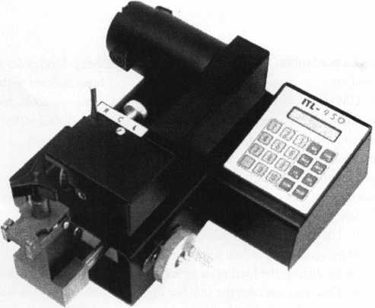

IITRALOCC

**TOOLS**

* NEW* INDUSTRIAL.  
ITL 9TOO  
CODE MACHINE

LIMITED

ITL 9000

Code Machine

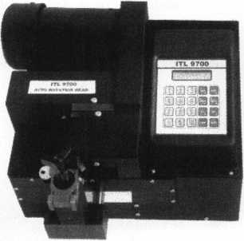

New MEDECO  
Autoswing head Option  
Cuts 6 pin Biaxial In 17 seconds

*Super bearing construction *Ball screw drive

* Superior Rigidity and Accuracy
* Shipped with carbide cutter

*2 year parts and labor warranty

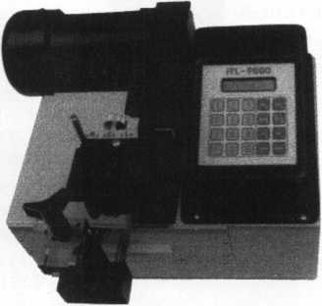

* Dependable heavy duty construction, one year parts and labor warranty.
* Serial port to connect to Reid,Treskat,Blackhawk and other second source code systems.
* Repeatable accuracy of 1/t000th inch.
* Cuts Medeco High Security key.
* Up to 800 built-in manufacturer depths & spaces.

— Now Distributed Throughout USA, Canada & Australia —

2639B Progressive Way • Abbotsford, BC Canada V2T6H8  
USA: 310-699-0060 • Canada: 504-352-8904 • Canada Fax: 504-352-5938 • Toll Free: 1-588-264-6627

Reader Service #7

Buyer’s

Guide



AABLE Locksmiths

Well once  
again GM has  
come out with

another ignition lock design, and Frank  
Markisello from AABLE locksmiths has  
designed a tool to simplify the removal and  
replacement of this new lock. His tool kit  
will allow you to remove a steel face cap in  
seconds. Then with the drill guide tool you  
can drill an access hole in line with the side  
bar without hitting the hard plate or the  
side bar. Then you can rake the side bar in,  
so you can turn cylinder to the “on” position  
for fast removal. Then just replace the cap  
and reinstall same lock. The first job will  
more than save you the cost of the tool kit!  
Contact Frank Markisello at (718) 847-

1377.

Reader Service #25

Alternative Tools

Here are new tools that  
address problems from an  
alternative point of view.

When the “usual” methods  
can’t get it done, try an  
alternative tool. “The Tool”

tension wrench is designed especially to  
allow more room for picks in SCI and KW1  
keyways. “Lever Up” lifts vertical auto lock  
linkage without disconnect danger and  
without the tool entering the vehicle. “Pad-  
dle Pusher” operates paddles and crash bars  
like you were standing inside. $12.95 each  
(+$4.95 S/H). Allow four to six weeks for

delivery. Send order on back  
of business card with check or m/o to:  
Alternative Tools, Inc.; 162 Robin Dr.;

Loveland, CO 80537.

Reader Service #26

BWD

BWD Automotive  
announces the new  
Lockcraft brand  
LC6177(U) and LC6180  
Ford 8-Cut ignitions and

SK6949 Chrysler 8-Cut Service Kit. Fitting  
virtually all 8-Cut vehicles, the new Lock-  
craft LC6177 (U) and LC6180 ignitions fit  
both transponder and non-transponder  
equipped Fords. The LC6177 is a coded lock  
supplied with non-transponder keys. The  
LC6180 is the same lock supplied with two  
transponder keys. The uncoded LC6l77U’s  
one-lock-fits-all feature, minimizes inventory  
and eliminates vehicle application problems.  
Warranty terms and conditions available  
upon request Contact (334) 874-9001.

Reader Service #27

Lucky Line Products, Inc.

Stock the most  
affordable key organizer  
available - the Lucky  
Line Key Organizer  
No.61000. Made of  
shatter-resistant

polypropylene, this rugged key cabinet hold  
up to 24 keys. The product installs in min-  
utes (screws provided). It measures 8-l/2"W  
x 10-1/2"H x 1 3/4"D and is perfect for  
home, office or garage. Contact:

(800) 654-6409.

Reader Service #28

|  |  |
| --- | --- |
| 34 ALOA’99 | IBC |
| 32 BWD | 42 |
| 7 ITL | 39 |
| 100 Jet Hardware Mfg., Inc.  33 Locksmith Publishing Corp  35 SAFETECH ’99 | BC  > 43  IFC |
| 24 Timemasters | 15 |
|  |  |
| Keynotes November 1998 | |

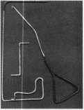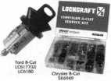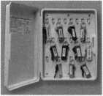

Milman Manufacturing

Customize your  
key chains to  
advertise your  
store, company or  
club. Simply send  
us your logo, art-

work or design and we’ll do the rest.  
Contact: (514) 425-5794;

FAX (514) 425-5793.

Reader Service #29

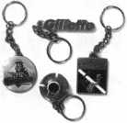

Rutherford Control Inc.

The Cabinet Lock  
is the ideal lock to use  
in small areas—and it  
takes only one second  
to reverse from failed  
locked to failed

unlocked! Because the lock’s catch bolt can  
be mounted on the side or the top of the  
lock, its flexibility is almost endless—  
applications include jewelry cases, key cabi-  
nets, dmg cabinets, cash drawers, access  
hatches and more. An optional monitoring  
switch is another feature which allows even  
greater application versatility. This compact,  
dual voltage lock features 100 lbs. holding  
force. Contact (800) 899-5625.

Reader Service #30

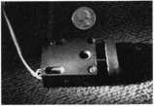

Slydelock Canada

Slydelock Canada is  
proud to introduce the  
SLYDELOCK. This  
unique design is engi-  
neered to securely lock  
your patio doors in its  
tracks. Made of lexan

plastic and reinforced aluminum alloy tub-  
ing, the SLYDELOCK lets you “lock open”  
your door by 5 inches. SLYDELOCK offers a  
life time product guarantee. Contact Gilles  
Pariseaw at (819) 770-1020.

Reader Service #31

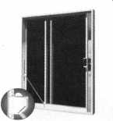

GET IN TOUCH WITH YOUR ASSOCIATION

**What’s going on at [www.aloa.org](http://www.aloa.org)? Oh, not much, just...**

**For those interested in becoming a professional locksmith, we offer:**

Getting Started in Locksmithing Regularly offered ACE classes Locksmith Schools

Contact information for the ALOA Education staff

**And, of course, there’s stuff just for you like:**

**Information for the public about you, the professional locksmith, including:**

**And we’re planning even more for 1999, so stay tuned.**

Urgent News Legislative Bulletins Upcoming Events Industry Happenings About Keynotes Magazine Members’ Bulletin Board Frequently Asked Membership Questions ALOA’s Convention and Security Expo The ALOA Store

Continuing Your Locksmith Education Becoming ALOA Certified Web Classifieds

ALOA’s Members in Mfg. and Distribution Industry Links Member Links

“Quick Contact” links to the ALOA staff

About ALOA Locksmiths Why Use a Professional Locksmith?

What Does A Professional Locksmith Do? ALOA’s Code of Ethics ALOA’s Certification Program ALOA’s Positive ID Policy History of ALOA

ALOA’s Technical Standards Policy Find a Locksmith [search function]



Keys

Locks

Kits

3 Training w Certification

For a FREE VATSmith information packet and  
locations of BWD Certified VATS Centers  
Call

See us at [www.alllock.com](http://www.alllock.com)

**Are You A  
BWD Certified  
VATSmith?**

**Wanna Be?**

Reader Service #32

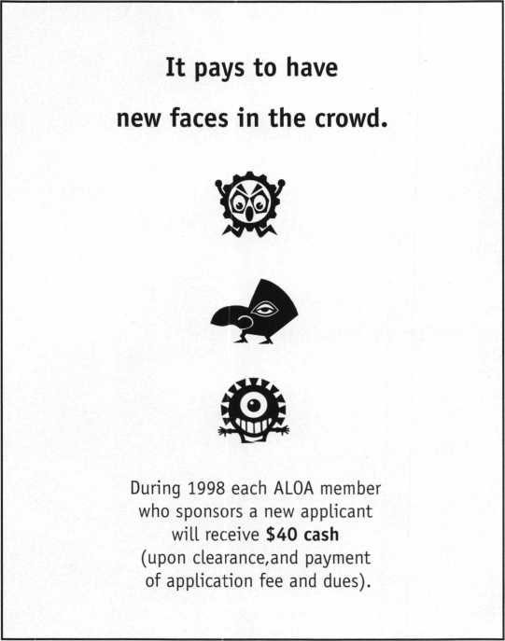

Keynotes

Authors

Dept

Authors featured in this issue of Keynotes:

Paul Chandler, CRL, is the manager of the Electronic Security Department for I.D.N.- ACME in Houston, TX.

Claire L. Cohen, the second woman to become a CML, has been in locksmithing since 1977 and has been writing articles for Keynotes since 1987.

I Sal Dulcamaro,

CML, has been in the locksmith  
business for over 23 years. He is the  
president of All Pro Security, Inc. in  
Michigan and has been an ALOA  
member for 16 years. A past president  
of the Locksmith Security Association  
of Michigan. Sal currently serves as  
editor of the association newsletter. He  
was named "Keynotes Author of the  
YeaP’ for 1996 and 1997.



Mike Emery is

the associate editor (/Keynotes  
and a freelance music, video and  
real estate writer.

Greg Perry has been in the locksmith industry for 18 years. He’s spent half that time as a field technician for the Security Engineering in Ridgecrest, Calif. Greg’s also a past president of Desert Counties Chapter of the California Locksmiths Association.

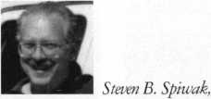

CRL, is a fourth generation locksmith who specializes in a variety of areas including crime prevention and institu­tional security. His broad experience in the security field spans 20 years of writing, teaching and consulting for a number of corporations. Most recently he formed Lockport, Inc.—a security consulting company for industrial, commercial, institutional and governmental clients.

Keynotes

November 1998

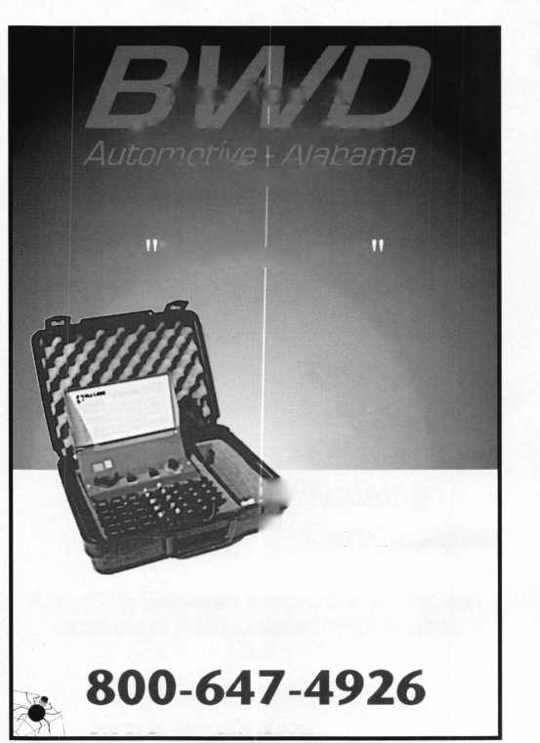

cksmith Ledger International

**JIK!** PleaseQ start

| 3 YEARS (includes 36 issues, 3 FREE Annual Directory* issues)

scription to

|  |  |  |
| --- | --- | --- |
| ■ IT U rM ^1 | £ 1 1 W i | | Wm |
|  |  |  |
|  | rTiTiMMTj !•] a t | 1 j[Q [•] i !• 11 |

USA $90.00

* 2 YEARS (includes 24 issues, 2 FREE Annual Directory* issues)

USA $64.00 Canada $91.00 International (air) $179.00 International (surface) $119.00

* 1 YEAR (includes 12 issues, 1 FREE Annual Directory* issue)

USA $38.00Canada $52.00International (air) $95.00International (surface) $65.00 • Comprehensive guide to industry manufacturers, distributors, products and services.

**CARD INVALID UNLESS COMPLETE DATA IS GIVEN**

You must indicate your locksmithing affiliation below

1. Are you a locksmith or an individual involved in locksmithing? □ YES □ NO
2. My position is: □Owner/Pres. Q3 Employee Q6 Student Q9 Other
3. Business classification (check one only): A □Locksmith Shop B □Hardware

C □Wholesaler/Distributor D □Manufacturer E □Security or Maintenance

1 □Consultant 3 □Industrial 5 □Government  
2QCommercial 4Qlnstitutional 6QPolice  
G □Architect/Specifier Z □Other (specify)

1. Are you involved in purchasing or influencing the purchase of locksmith products?

**□ yes Qno**

**Send payment to: Locksmith Publishing Corp. • 850 Busse Highway • Park Ridge, IL 60068  
Phone: 847-692-5940 • Fax: 847-692-4604 ■ • Website: [www.lpc.simon-net.com](http://www.lpc.simon-net.com)**

Reader Service #33

Name

Company

Address

CityStateZip PhoneFax

Payment: (US FUNDS ONLY) Money OrderCharge CardCheck #

Complete for Charge Orders Only: VISA Master Card

Account #Exp. Date Signature

IM8

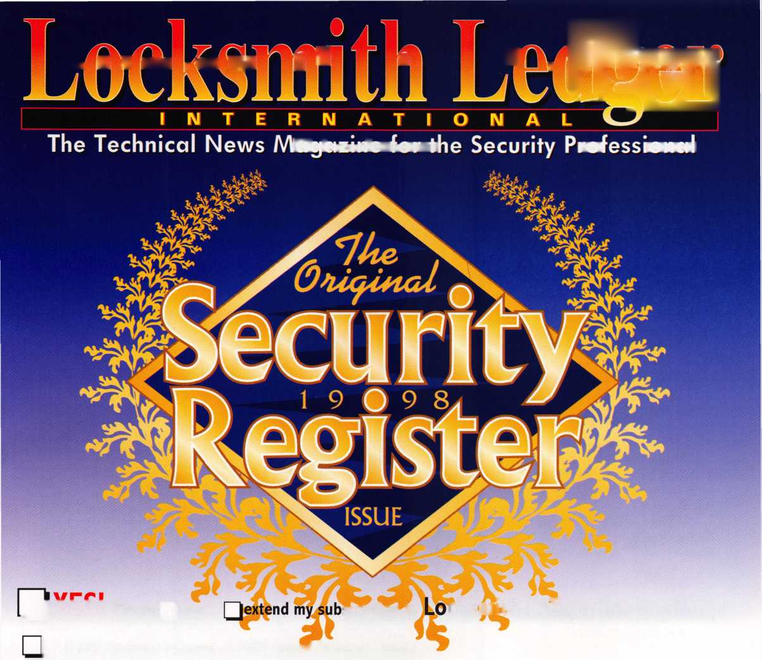

Back

F'age

Did You Know There Is More Than One?...

There’s the kind of locks you put on doors. There’s the kind of lox you put on bagels.

There’s track superstar Michael Johnson. There’s Michael Johnson (#15190) with Mike’s Lock & Key in Cannon Falls, Minn.

There’s the city of Paris in France. There’s the city of Paris in the state of Texas, USA.

There’s the John Grisham that wrote The Firm and The Client. There’s the John Grisham (#12165) that’s the locksmith for the Santa Clara school district.

There’s the Charlie Brown in the Peanuts cartoon strip. There’s the Charlie Brown (#16225) in Orange, California.

There’s the James Taylor who sang Up on the Roof and You’ve Got A Friend. There’s James Taylor (#428) of Taylor Resources Inc. in Lexington, KY.

There’s the Coney Island across Hudson Bay from New York City. There’s the Coney Island in Cincinnati with the world’s largest recirculating pool.

Send us another “two of a kind'’ and you’ll be entered in a drawing for four

passes to the Coney Island Sunlite Pool and Classic Rides. And plan on registering early for the ALOA ’99 Convention and Security Expo, July 25-32, [www.aloa.org/industry/expo.cfm](http://www.aloa.org/industry/expo.cfm) (website).

Name

Member#

Two of a kind:

“There’s

and there’s”

Send responses to:

Fax: (214) 827-1810;

Email: [keynotes@anet-dfw.com](mailto:keynotes@anet-dfw.com) (email); or Mail to:

Two of a Kind!

3003 Live Oak Street Dallas, TX 75204



Keynotes

November 1998



Plan now to be in the coolest place of all next summer.

Dive into a class, make a splash at a seminar and wave to your friends as you drift through the nation’s largest exposition of locksmith related manufacturers.

Refresh your spirit with a visit to Fountain Square, a ride on a riverboat, or by enjoying the breathtaking river view from Mt. Adams.

ALOA ’99 will be the coolest yet! Call for details: 800.532.2562, or visit our website: [www.aloa.org](http://www.aloa.org).

CINCINNATI

**Hi j Jliji j§§ 11 jjjjjji - 11**

Reader Service #34



**Don't Be Locked Out of the Electronic**

**Key Market**

sss:

K

The ETD-1... Transponder Key Duplication made Easy.

Don’t be locked out of the growing market of electronic anti-theft automotive security. This easy-to-use decode quickly and accurately duplicates the most popular transponder keys, including: CADILLAC CATERA, HONDA, ACURA, MAZDA and AUDI / VOLKSWAGEN. Included with your purchase are 5 each of the above keys (a value of $ 295.00), along with a colorful windov decal.

Available through your favorite JET distributor.

JET HARDWARE MANUFACTURING CORP

800 Hinsdale Street, Brooklyn NY 11207

Reader Service #100

